|  |  |  |  |
| --- | --- | --- | --- |
|  |  | Datum | Vår ref |
|  | 2024-09-04 | Rolf Sjöblom |
|  |  |  |
|  |  | Er ref |
|  |  | Carolyn Pearce |

**DRAFT**





|  |  |
| --- | --- |
|  | PNNL |
|  | Carolyn Pearce |
|  |  |
|  |  |

**Information search on influence of heat on the stone material in the vitrified wall at Broborg**

**Memorandum**

**Rolf Sjöblom**

**Tekedo AB**

**September 2024**

ABSTRACT

Possibly an abstract might be written as well as some identification of what might be done to increase the present knowledge. As of today, I suggest that this be left until there has been a dialogue with PNNL.

CONTENT

ABSTRACT ii

CONTENT iii

1 BACKGROUND AND INTRODUCTION 1

1.2 General background 1

1.2 Purpose and scope 3

1.3 The reference search Excel file 4

2 ABOUT THE TYPES OF ROCK AND MINERALS INVOLVED 5

2.1 Rock types 5

2.2 Minerals 8

2.3 Some data from thermal analysis and calorimetry 11

2.4 Occlusions and occluded water; liquid-liquid fractionation 18

2.5 Further comments on the possible reality during the firing of a wall in a hillfort 21

3 THERMALLY MODIFIED ROCK (TMR) AND MECHANICAL PROPERTIES 24

3.1 Introduction 24

3.2 From archaeological sources; cooking stones 25

3.3 Thermo-mechanical behavior; natural sciences sources 31

3.3.1 Introduction 31

3.3.2 Crystallographic considerations 33

3.3.4 Heating experiments 34

3.4 Summing up on thermo-chemical and thermomechanical properties before sintering 43

4 SINTERING AND NEAR-SINTERING BEHAVIOR 45

4.1 The challenge 45

4.2 Prerequisites for sintering 45

4.2.1 Introduction 45

4.2.2 Kaoline and the manufacturing of ceramics 45

4.2.3 Roasting of iron ore 48

4.3 The sintering process 50

4.4 Infilling of fractures 52

4.4 The modern versions of the vitrified rock at Broborg 53

# 1 BACKGROUND AND INTRODUCTION

## 1.2 General background

The present memorandum relates to the work being carried out within the Broborg project aiming at qualifying the ~ 1500 years old glass from the hillfort Broborg in Sweden for use as an analogue for certain nuclear waste that has become immobilized by means of vitrification. One important aspect in this regard is to understand the genesis of this glass which includes its properties (initial and at present) and how it was created.

The inner wall at Broborg has a circumference of around 200 m of which around 150 m are vitrified to a depth of 0,5 m and a width of around 1 m. The vitrified part comprises pieces of gneissic granite and amphibolite which have been sintered together. As described in detail elsewhere, the microstructure contains two kinds of glass, “clear glass” and “dark glass” as well as various crystalline phases. The sintering has led to a mechanically very robust base for a wall on top which today is completely disintegrated.

It has been assessed elsewhere that this vitrified wall was created for the purpose of constructing the fort. Hillforts were subjected to recurrent attacks and therefore had to be constructed to withstand severe forces. For the most part, and in general, this appears to have been achieved by means of reinforcements of logs in the stone structures. However, timbers towards the base of a wall were most susceptible to rot at the same time as they were the most difficult ones to replace, and this may have been an important rationale in order for the ancient people to make the effort to construct a more durable vitrified wall.

There are several points of proof that have been put forward for the interpretation of constructive purpose. The perhaps strongest one is the observation made by Kresten that the amphibolite in the vitrified wall at Broborg was enriched by a factor of ten in relation to the “natural” abundance in the neighborhood. Thus, the pieces of amphibolite (diorite/diabase/microgabbro) rock welded or sintered the different pieces of rock – amphibolite and gneissic granite – together to form a mechanically very strong entity. It has been described by participants in the previous excavation (i. e. in the years 1982-83) as “concrete-like”

It was observed during the recent excavation carried out by the project that a digging bar in combination with a heavy sledge hammer were required in order to penetrate the vitrified part. Subsequent tomographic investigations carried out by PNNL have shown that the amphibolite obviously had expanded in a semi-molten stage through the action of pockets of entrapped gases (vesicles) in which process pieces of amphibolite and neighboring pieces of granitic rock had become “glued” together and formed strong bonds with each other.

Actually, the amphibolite contains far more bound water than what corresponds to what reasonably might be the content in the vesicles. Thus, it seems that a minor part of such water is bonded much more tightly than most of it. Moreover, there are indications in the literature (Kresten) that the melting process might be strongly influenced by the containment of the fire (the cover containing water), and thus including the presence of water vapor, oxygen, carbon monoxide and hydrogen.

Moreover, underlying large stones of granitic rock appeared to be rather unaffected by the heat. (These stones were surrounded by what might have been channels for access of air to the charcoal used to supply the heat required.)

Anyone that has been involved in the development of new materials and new chemical processes knows that it is unlikely that one arrives at a solution close to the optimal one – let alone a functioning one – on the first attempt. It would indeed be remarkable if the vitrified wall at Broborg would have been the result of a first attempt.

The capability of ancient people to arrive at efficient solutions just because they did not have access to modern concepts of chemistry should not be underestimated. The ancient Roman concrete, e. g., proves this statement. Such constructions are largely intact still today, and this is something that, for various reasons, cannot be expected for modern concrete made using Portland cement and reinforced with iron bars.

It is not to be expected that we today will be able to find out how the ancient people went about in order to develop their vitrified wall process. However, it may be possible for us, using modern knowledge and techniques for measuring, to identify potential obstacles and how they might have been circumvented and managed.

Here follows some examples of potentially salient points:

* Splitting of rock, fire cracking, due to uneven heating, including the effect of temperature differences during heating. (Actually, localized heating is sometimes being used in order to fracture boulders; i. e. this is an alternative to blasting)
* Creation of less severe TMR (Thermally Modified Rock) fracturing due to heating, even or uneven. Such damage does not include splitting, and the damages may not be visible. In the ceramic industry, such damages are frequently identified by striking the ceramic body with a hard object and listen to the sound.
* Formation of volatiles before the melting begins leading to disintegration. It is possible, however, that a piece of rock be porous enough in order for such gas to pass through it, especially if the gas is able to diffuse through interstitial spaces in the crystal structure (such as can be the case for hydrogen in particular, see further below).
* Release of volatiles during sintering:
  + Too much gas leading to disintegration of the amphibolite
  + Too little gas leading to inadequate expansion and consequent bonding between the various pieces of rock
* Fate of fractures formed through thermal expansion during heating:
  + No fracture filling and pieces of rock damaged
  + Filling of fractures by melt from the pieces of rock present
  + Filling of fractures by fumes containing KCl and NaCl which lower the melting point on surfaces where they react with Si-containing material
* Difficulty to achieve an even temperature throughout the parts of the wall to become vitrified
* Influence on melting characteristics by:
  + Control of H2O vapor, CO, CO2, H2.
  + And thereby also indirectly by Fe-2/Fe-3
* Selection of rock quality, especially for amphibolite
* Selection of process parameters, e. g. temperature cycle and thermal conduction (e. g. by choice of sizes for the pieces of rock). It should be observed that specific heat and thermal conductivity change quite a bit with temperature. Specific heat increases with temperature, which, together with the heat of fusion, implies that much of the calories of heat required need be provided at and near the highest temperatures.
* Selection of fuel considering the need for calories at the highest temperatures
* Supply of air or forced air to achieve the temperature conditions required
* Sameness for each type of rock used

## 1.2 Purpose and scope

This memorandum together with the associated reference search document and data base (an Excel file) summarize the results of an information search carried out on commission by Pacific Northwest National Laboratory (PNNL) to Tekedo AB. The work covers possible and potential effects of heat, atmosphere and time on the stone material in the vitrified wall at the hillfort Broborg in Sweden. The purpose is to supplement the much more extensive and comprehensive work that has been and is being carried out by the colleagues in the project in the United States.

The objective is thus to support the colleagues in the US in their efforts to interpret experimental data and to find explanations to the data obtained during the experimental investigations of pristine samples from the ca. 1500 years old wall.

This work focusses on the events that took place during heating. They are assessed to be more closely related to the mechanical integrity of the vitrified part of the wall as compared to the events during cooling. Moreover, it is less difficult to identify - by means of laboratory investigations - the events during cooling as compared to those during heating.

It was intended initially, that there would be two memoranda, one for Thermally Modified Rock (TMR), and another for sintering and related mechanisms. However, it became apparent during the course of the work, cf. above, that these processes are strongly interrelated and are therefore dealt with in a single document, i. e. the present memorandum. E. g., fractures might weaken the structure, but, on the other hand, fractures that have been filled with melt and healed through sintering might do the opposite.

## 1.3 The reference search Excel file

An information search was conducted covering mainly scientific literature (in digital form as well as on paper) in various related areas, notably including natural sciences as well as arts / archaeology. Pages of particular interest were “earmarked” using post-its. A list was made using search words, and batches of references were included in an Excel file, one page for each batch. The batches were labelled as follows: II, III, IV, IVd, IVe, IVe2, IVe3, IVe4, and print. Batches II – IVe4 comprise digital sources, and print refers to sources on paper. The total number of entries exceed 250 of which around 20 % are on paper.

The entries appear in a short-hand notation and comprise the following: first author, title (e. g. chapter) / catalogue, first editor, title (e. g. book), year, and search words together with comments. The comments comprise short-hand notes of content thought to be of interest.

Included in the package submitted to PNNL is also the digital files. They are arranged in batches as well as in catalogues, cf. above.

The idea is that the colleagues in the US should be able to use this database for themselves in their research.

The present memorandum summarizes the major findings in the information search. A finding here is sometimes a conclusion, but often just an indication of that something might be the case, thus requiring further, often experimental, work, if any conclusion is to be made.

Moreover, this memorandum does not provide any full accounts of the content of the documents, only somewhat arbitrary examples supporting the points made in the present memorandum. A more comprehensive information can be obtained using the search words as well as the notes made in the Excel file.

Of course, the need for details from the present sources will depend on the particular experiments and associated need for information in the ongoing and future work at PNNL.

# 2 ABOUT THE TYPES OF ROCK AND MINERALS INVOLVED

## 2.1 Rock types

It is assumed, in this memorandum, that the reader either has or acquires the general mineralogical and chemical background necessary. As regards the present rock types, it is assumed, in particular, that the reader is familiar with the paper by McCloy et al. (2021), see IVe4/3.

Nonetheless, some characteristics of particular importance for the analysis are still mentioned. Thus, the content and character of bound water is likely to be very significant for the mechanical properties as well as for the melting characteristics.

The rock types in question are granite and amphibolite that was available for the ancient people at and around the hillfort Broborg, see (IVe3/10; III/71). As mentioned in IVe4/3, the granite originates from field stones that had been removed from the bedrock and then moved around by the glaciation(s). Thus, they originate from further away than the immediate vicinity of the fort, and consequently have varying compositions and textures. These pieces of rock are therefore frequently referred to as “granitoides” or “gneissic granite”, but will in the following be referred to as just “granite”.

Similarly, the amphibolite might originate from fieldstones (as mentioned in one of Kresten’s papers), but may also have been mined from various outcrops, one of which is located at the Broborg hill itself. Various samples analyzed in IVe4/3 show varying contents of the constituent minerals

As the content of bound water is significant for the fracturing as well as for the melting processes, it need be pointed out that such content is neither apparent from the appearance of a piece of rock, nor – many times – from its name. Actually, water behaved very differently when these rocks were formed deep in the crust as compared to ambient surficial conditions, see (print/37, p. 204) which is presented in Figure 2-1.

Granite as well as amphibolite at Broborg are considered to be intrusive igneous rock, meaning that the rock has solidified from melt at some depth in the crust. This implies that the rock has often kept whatever water that was in the melt and mostly done so in the form of bound water. In the case of granite, some water may be present in the form of “free” / liquid water in the form of inclusions.

Granite typically, as well as at Broborg, consists of the minerals quartz, feldspar and mica where most of the latter is biotite and some is muscovite. However, granites might have become “dehydrated” at some time during their geological history, in which case pyroxene might be present instead of biotite. Pyroxene does not contain bound water.

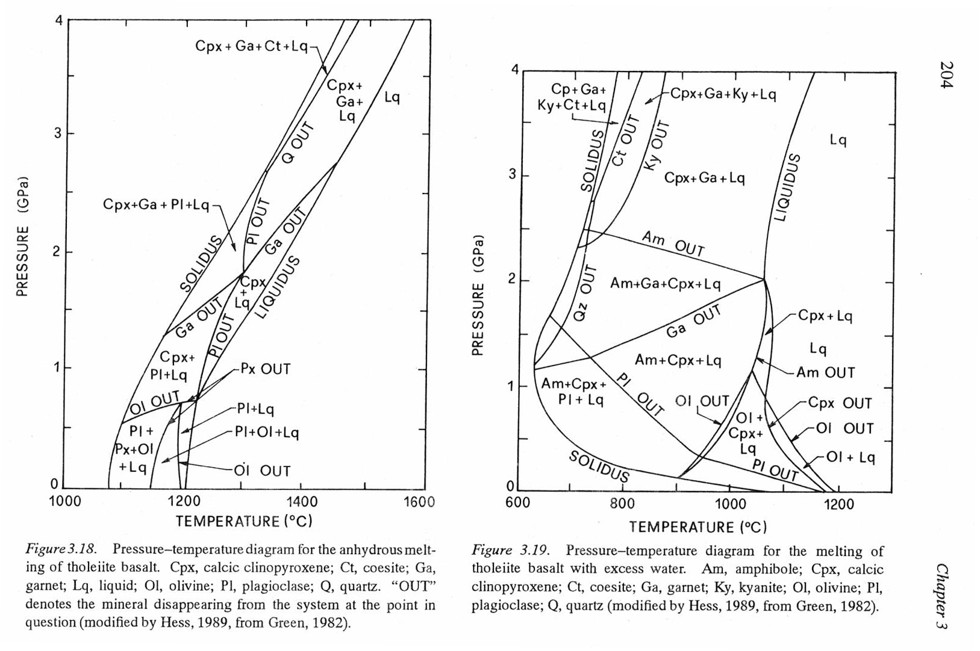

Figure 2-1. See text in the figure. From (print/37, p. 204).

Amphibolite carries its name because it contains high levels of amphiboles. Amphiboles have been referred to as the “waste basket” in mineralogy because they appear in a wide variety of rather complex mineral compositions (print/11, p. 2). In the case of Broborg, we are probably (cf. proint/42 p. 238-, see also Encyclopedia Britannica, <https://www.britannica.com/science/diabase>) dealing with what is referred to as calcic amphiboles which includes hornblende. According to Wikipedia “hornblende” includes at least five solid solution series between endmember individual amphiboles. The amphibolites at Broborg IVe4/3 also contain mica, feldspar and silica as determined by x-ray powder diffraction and Rietveld analyses. The contents of the different phases vary quite a bit between different outcrops.

The amphibolites at Broborg can also be referred to as diabase (or dolerite, or microgabbro). According to Wikipedia (<https://en.wikipedia.org/wiki/Diabase>; (IVe4/4): “*Diabase is the preferred name in North America, while dolerite is the preferred name in the rest of the English-speaking world, where sometimes the name diabase refers to altered dolerites and basalts. Some geologists prefer to avoid confusion by using the name microgabbro*.”.

In the following, the name diabase will be used, which also concords with the name in Swedish, “diabas”. Diabase is a mafic rock, as opposed to granite which is felsic. Thus, the content of silica in diabase is comparatively low but normally, the content of plagioclase is still quite high. Diabase may contain amphiboles and micas (including e. g. biotite), i. e. hydrous minerals, or pyroxenes, i. e. anhydrous minerals.

Granites containing bound water may have a very similar appearances as compared to those that do not, and the situation is the same for diabases. Moreover, presence of bound water does not (readily) reveal itself in an ordinary elemental analysis. Differences might be observed through analysis of thin sections, but a more potent tool is the above mentioned x-ray analysis in combination with Riedveld analysis. Alternatively, and/or additionally, thermogravimetry and differential thermal analysis (or differential scanning calorimetry) might also be used.

These questions have important practical implications when the hazards of fire in tunnels are to be evaluated (IVe4/6). It is mentioned that “*The loss of crystal bound water caused also the rocks to become very friable and susceptible to failure*”. See also IVe4/8. Further information on this is provided in 3.3.4.

Similar conclusions are drawn in publications on the use of diabase for the purpose of heat storage at temperatures around 675 °C (IVe4/5). Here, some fracturing is ascribed to the presence of “*iron-bearing and hydrous material*”. One of the main conclusions is as follows: “*Rocks with anhydrous minerals with a high heat capacity (e.g. pyroxene, olivine, oxides) are ideal for HTTES systems*”. (HTTES stands for High Temperature Thermal Energy Storage).

The following is concluded in a review article on thermal energy storage (IVe4/12): “*It is clear that the thermal stability of these materials is affected by thermal cycling process at high temperature, since their forms and their structural features undergo some variations after heat treatment. Also, they could be cracked, disintegrated or fractured, and formed some micro-cracks. This change is mostly attributed to decarbonization reactions, dehydration of minerals, and anisotropic thermal expansion of minerals, precisely the α-β phase transition in the Quartz. Hence, it is necessary to determine the temperature application range of rocks considering their chemical compositions in order to avoid the onset of the majority of chemical reactions that could affect the stability of rocks.*”

There is a reminiscence today of the historic and prehistoric use of heating stones, namely in a sauna. Here the stones are heated either by a wood fire or by electric heaters. Water is then put on the hot stones to generate steam that heats the entire space. Thus, the stones need to be resistant towards thermal shock. According to French Wikipedia, see <https://fr.wikipedia.org/wiki/Sauna>, the following types of rock are suitable for this purpose: diabase, gabbro, olivine and soapstone. Maybe they utilize varieties with little or no bound water.

Thus, the thermal properties, be it mechanical integrity or sintering and melting behavior are highly dependent on the chemical compositions as well as the structural properties. This will therefore be dealt with in the following.

## 2.2 Minerals

A crystallographic phase can be represented by a crystallite that can generate a unique set of x-ray reflections. Here, the positions of the reflections are defined by the lengths of the axes of the unit cell together with the angles between them, i. e. the cell parameters. The content of the unit cell, i. e. the various atoms as well as their positions are given by the various intensities of the reflections. Still ideally, such a unit cell is repeated in three dimensions throughout the crystallite.

In reality, nature is much more complex. Different atoms may substitute for each other in more or less ordered ways. Often silicate-aluminate backbones may be subjected to various substitutions of cations. This gives rise to classes of phases which are intermediate to the various end members.

As mentioned briefly above, amphibole has been described as the 'garbage can' or 'waste basket' ... or 'sponge' … that does not discriminate among the constituents tossed into it; a mineralogical shark in a sea of unsuspecting elements (print/11, p. 2).

This view might have become somewhat altered in Volume 67 of the reviews in Mineralogy in which much focus is given to results obtained using modern tools such as the electron microprobe. The following quote from (print/32, p. 359) might be read to mean that the ranges of solid solution are now assessed to be smaller than previously thought:

“*Amphiboles can have contents of all the major elements and a few minor elements that are measurable in weight percent. Before the widespread use of electron microprobe provided for better characterization of amphibole compositions, the early recognition of its compositional range and diversity from gravimetric analysis led to amphiboles being regarded as sponges (Engel and Engel 1962) and waste baskets and garbage cans (Ernst 1966) or even as mineralogical sharks in a sea of unsuspecting elements (Robinson et al. 1982) that indiscriminately absorbed, received and consumed elements*.”

It should be remembered, though, that miscibility in the solid state is not the same as thermodynamic disequilibrium. The Gibbs free energy depends on both the enthalpy and the entropy (as well as the temperature).

As also mentioned above in Section 2.1, amphiboles can be divided into several groups and sub-groups where amphiboles at the Broborg site might be expected to belong to the group “calcic amphiboles” and its subgroup “hornblende”, see Encyclopedia Britannica, <https://www.britannica.com/science/diabase>. A brief description of hornblende can be found in (IVe4/7; <https://en.wikipedia.org/wiki/Hornblende>), and the part about composition is as follows:

*“Hornblende is part of the calcium-amphibole group of amphibole minerals.*[*[10]*](https://en.wikipedia.org/wiki/Hornblende#cite_note-FOOTNOTENesse2000278-10) *It is highly variable in composition, and includes at least five solid solution series:*

* *Magnesiohornblende–ferrohornblende, Ca2[(Mg,Fe)4Al]Si7AlO22(OH)2*
* [*Tschermakite*](https://en.wikipedia.org/wiki/Tschermakite)*–ferrotschermakite, Ca2[(Mg,Fe)3Al2]Si6Al2O22(OH)2*
* [*Edenite*](https://en.wikipedia.org/wiki/Edenite)*–ferroedenite, NaCa2(Mg,Fe)5Si7AlO22(OH)2*
* [*Pargasite*](https://en.wikipedia.org/wiki/Pargasite)*–ferropargasite, NaCa2[(Mg,Fe)4Al]Si6Al2O22(OH)2*
* *Magnesiohastingstite–[hastingsite](https://en.wikipedia.org/w/index.php?title=Hastingsite&action=edit&redlink=1" \o "Hastingsite (page does not exist)), NaCa2[(Mg,Fe)4Fe3+]Si6Al2O22(OH)2*

*In addition,* [*titanium*](https://en.wikipedia.org/wiki/Titanium)*,* [*manganese*](https://en.wikipedia.org/wiki/Manganese)*, or* [*chromium*](https://en.wikipedia.org/wiki/Chromium) *can substitute for some of the cations and oxygen,* [*fluorine*](https://en.wikipedia.org/wiki/Fluorine)*, or* [*chlorine*](https://en.wikipedia.org/wiki/Chlorine) *for some of the* [*hydroxide*](https://en.wikipedia.org/wiki/Hydroxide) *(OH). The different chemical types are almost impossible to distinguish even by optical or X-ray methods, and detailed chemical analysis using an electron microprobe is required.*[*[11]*](https://en.wikipedia.org/wiki/Hornblende#cite_note-FOOTNOTENesse2000285-11)

*There is a solid solution series between hornblende and the closely related amphibole minerals,* [*tremolite*](https://en.wikipedia.org/wiki/Tremolite)*–*[*actinolite*](https://en.wikipedia.org/wiki/Actinolite)*, at elevated temperature. A* [*miscibility gap*](https://en.wikipedia.org/wiki/Miscibility_gap) *exists at lower temperatures, and, as a result, hornblende often contains exsolution lamellae of* [*grunerite*](https://en.wikipedia.org/wiki/Grunerite)*.*[*[12]*](https://en.wikipedia.org/wiki/Hornblende#cite_note-12)*”*

Biotite can also be considered to be intermediate between some end members, and here is a quote from Encyclopedia Britannica (IVe3/6; <https://www.britannica.com/science/biotite>).

“*Biotite is regarded as a mixture composed of variable proportions of four basic aluminosilicates of* [*potassium*](https://www.britannica.com/science/potassium)*,* [*iron*](https://www.britannica.com/science/iron-chemical-element)*,* [*magnesium*](https://www.britannica.com/science/magnesium)*, or aluminum: annite, K2Fe6(Si6Al2*[*O*](https://www.britannica.com/science/oxygen)*20)(OH)4; siderophyllite, K2Fe5Al(Si5Al3O20)(OH)4;* [*phlogopite*](https://www.britannica.com/science/phlogopite)*, K2Mg6(Si6Al2O20)(OH)4; and eastonite, K2Mg5A1(Si5Al3O20)(OH)4. Biotite is arbitrarily designated as having a magnesium-to-iron ratio less than 2:1.”*

An example of compositions and how they vary within one site can be found in (IVe3/12), see Figure 2-2. Further examples of compositions as well as variations between different sites can be found in (IVe3/13-15).

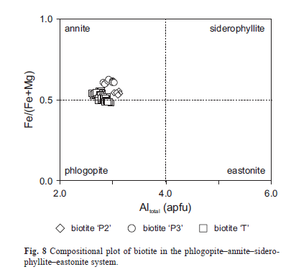

Figure 2-2. An example of the variations in compositions for biotite at one site. Observe that due to the restrictions on the Mg to Fe ratio only part of the space in the figure represents biotite.

A common feature of the chemical compositions of biotite and hornblende is that they all contain bound water. The name Biotite implies that the content of iron is above a certain level, see above, and it seems that iron is also present in the hornblendes, at least in most cases. Furthermore, and according to the above, iron in biotite is always (maybe mostly in practice) iron-II. For hornblende, and again according to the formulas, iron is iron-II for the most part, although the structures also have sites suitable for iron-III, which of course might be occupied to varying extents.

Just judging from the chemical formulae and the positions available, it appears that hornblende might be more resilient towards oxidation as compared to biotite. No information search has been made with this in mind, however.

So far about similarities, but it is also apparent from the above that there may be “room” for a lot of variations in the compositions in general, and related, in the various properties. No data has been found, or is believed to exist, regarding the variations of the compositions of the minerals in the amphibolite and granite at Broborg. It should be pointed out though, that there exists no basis for just assuming that they are similar. Rather, the fact that the compositions in terms of content of amphibolite and biotite are quite different calls for caution with regard to the content of the various crystalline phases.

It might be tempting to conclude that any such compositions would nonetheless be similar between each of the granite pieces of rock and those for amphibolite at the Broborg site. However, it is more likely that chemical as well as mineral compositions are dissimilar even between pieces of rock adjacent to each other. During the latest glaciation, Broborg had an ice cover of around 2.4 kilometers, much more than in any other country in Europe. The high ice cover caused strong forces detaching pieces of rock from the bedrock, abrasing them and moving them around. Thus, the compositions of the various pieces of rock at Broborg can be expected to be dissimilar. An exception to this might be if the ancient people would have mined the amphibolite from an outcrop. Obviously, any such case could readily be identified by means of ordinary total chemical analyses.

The known and possible variations in the compositions of the various phases and rocks call for caution with regard to how literature should be interpreted. In this regard, literature can indicate, through comparison, what might conceivably be the case for specimens for Broborg, but due to the just mentioned differences, such conclusions might well be erroneous. In other words, literature can provide a basis for what to look at, but conclusions should preferably be based on data from actual local samples.

## 2.3 Some data from thermal analysis and calorimetry

Some basic data on the thermal properties can be found in the following books:

Print/41 Smykatz-Kloss, 1974: Differential thermal analysis, application and results in mineralogy.

Print/42 Grapes, 2006: Pyrometamorphism.

Print/51 Gallagher, 2003: Ceramic glass, and electronic materials. In: Brown: Handbook of thermal analysis and calorimetry. Volume 2, applications to inorganic and miscellaneous materials.

Print/52 Meyers, 2003: Thermal analysis of clays. In: Brown: Handbook of thermal analysis and calorimetry. Volume 2, applications to inorganic and miscellaneous materials.

Print/53 Smykatz-Kloss, 2003: Application of thermal methods in the geosciences. In: Brown: Handbook of thermal analysis and calorimetry. Volume 2, applications to inorganic and miscellaneous materials.

(print/41): p. 63-64 are about ”*Ortho-, ring-, and chain silicates”. “van der Plas and Hügi reporting the dehydration of amphiboles lying at temperatures about 1000 °C*.” … “*Freeman found out increasing dehydration temperatures of amphiboles (>980 °C) with increasing contents of magnesium.*”

(print/41): p. 71 are about micas and chlorites. Mica includes biotite. “*The preparation of mica samples for DTA investigations has to be made very carefully: only fine-grained micas show DTA effects, but sheets of cleavage show none. But grinding in a ball mill (for at least 3 hours) must not be too strong, since otherwise the structure of the micas will be partly destroyed. Then the decomposition peak will appear 100 – 200 °C earlier (instead of 850 °C) in the DTA curves of such partly destroyed micas.*”

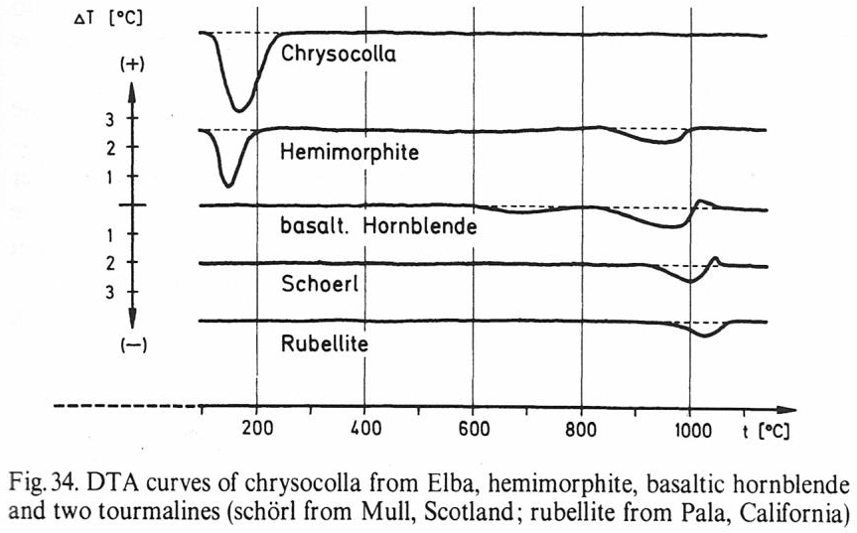

Figure 2-3. From (print/41 p. 63), see original figure text. Some DTA (Differential Thermal Analysis) curves of some Ortho-, ring-, and chain silicates. See text in the figure. Hornblende is an amphibole, and “basaltic hornblende” might be similar to the amphibole in the amphibolite at Broborg. Note the small endotherm at around 700 °C indicating that some chemical reaction is going on already at this temperature.

(print/41): p. 73: “*The sedimentary micas loose water which has only been bound absorptively between 120 and 300 °C and OH- which has been part of the octahedral layers between 500 and 650 °C. They are decomposed between 850 and 940 °C as in the case of magmatic micas, and begin to sinter after 1100 °C.” … “Biotites, moreover, sometimes show a strong exothermic effect between 400 and 600 °C, due to oxidation of bivalent iron (see Fig. 42).*” This figure is presented in the present memorandum as Figure 2-4.

(print/52), p. 278-279: The text refers to Figure 11 which includes a DTA curve for biotite. However, the curve for this mineral appears to be the same as in Figure 2-4, and is therefore not reproduced here. “*Micas that contain iron, such as biotite and zinnwaldite, show an exotherm between 300-500 °C, corresponding to the oxidation of Fe2+.”* Muscovite does not seem to oxidize, and it does not contain any iron.

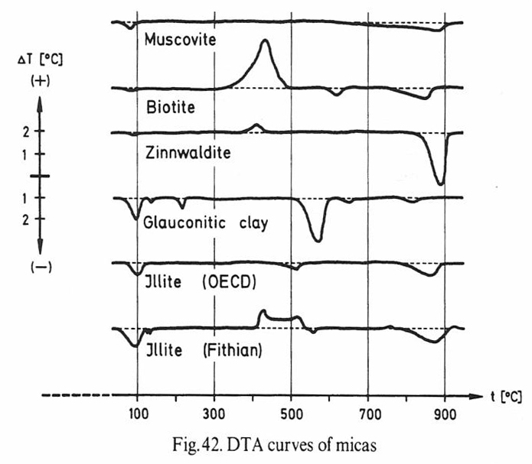

Figure 2-4. From (print/41, p. 74), see original figure text. DTA curves for biotite and some other micas. From (print/41): p. 74.

(print/53), p.481: “*Figure 21{reproduced here as Figure 2-5} shows the DTA curves of the different mica types, e. g. muscovite, biotite, zinnwaldite, glauconite, illites. The exothermic effect at 400 °C mirrors the content of some divalent iron (biotite, zinnwaldite, Fithian illite). Micas show a thermal behaviour strongly depending on their petrographic history. Micas from igneous or metamorphic rocks, which exhibit a high degree of order in their structures, dehydroxylate and decompose at higher temperatures than sedimentary soil micas (e. g. illites, glauconites, see [24, 158, 179, 211, 212]. The de*

*hydroxylation of micas occurs in the temperature range between 700 and 1050 °C. At temperatures > 1000 °C they start to sinter. As shown in the degassing experiments of biotite, water and fluorine escape first (Figure22)*.” Figure 22 is reproduced here as Figure 2-6. “*Under the same conditions, the thermal decomposition of muscovite occurs with a maximum at 800 °C (Figure 23) and water and fluorine escape simultaneously*”. Figure 23 is reproduced here as Figure 2-7.

Print/53: p 483: Vacuum: Fig 2-6 H2 release from biotite starts at around 800 C, max at ca 1150 C. Water release at 1150 C; it is higher than H2. Fig 2-7 H2 and H2O release from Muscovite at 800 C; the latter higher.

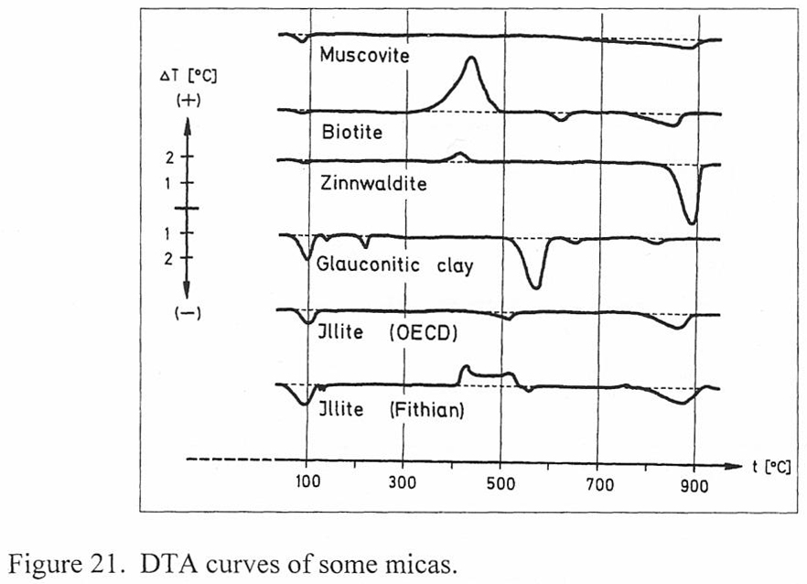

Figure 2-5. From (print/53 p. 482), see original figure text. DTA curves of biotite and muscovite as well as a few other micas.

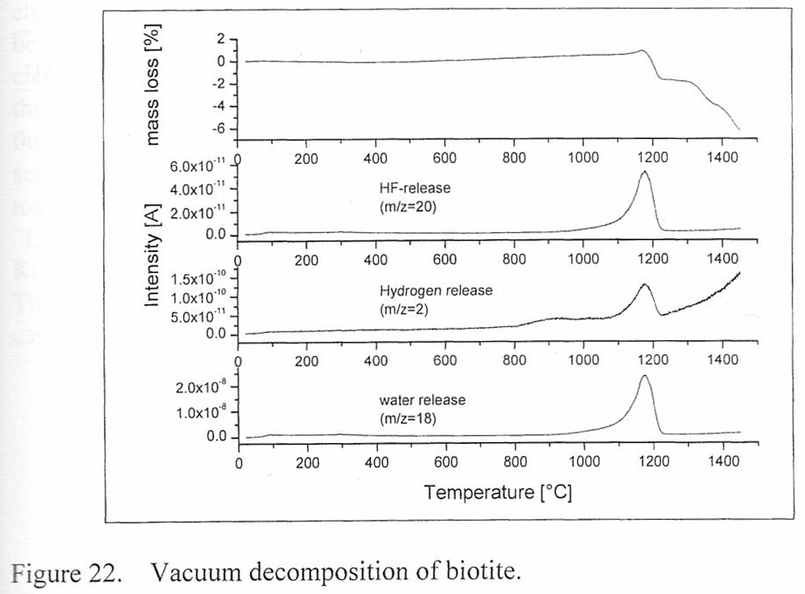

Figure 2-6. From (print/53 p. 483), see original figure text. Vacuum decomposition of biotite.

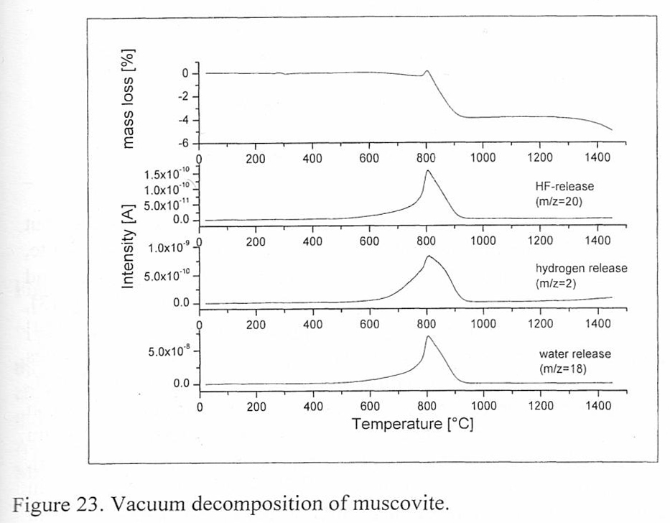

Figure 2-7. From (print/53 p. 483), see original figure text. Vacuum decomposition of muscovite.

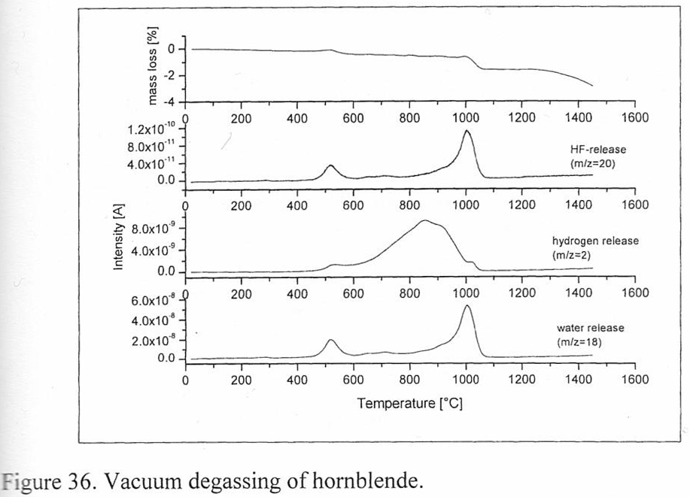

Figure 2-8. From (print/53 p. 505), see original figure text. Vacuum degassing of hornblende.

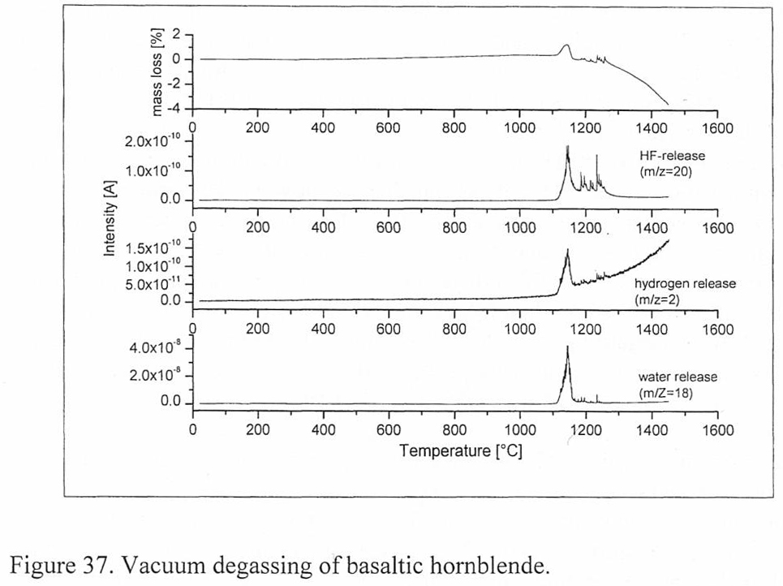

Figure 2-9. From (print/53 p. 506), see original figure text. Vacuum degassing of basaltic hornblende.

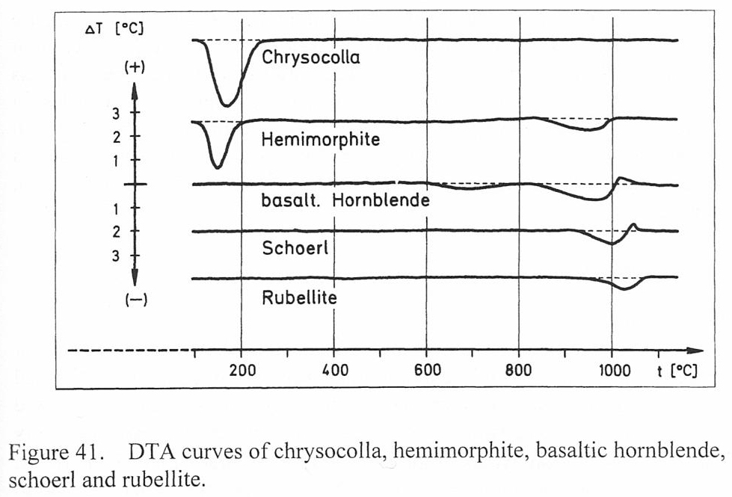

Figure 2-10. From (print/53 p. 511), see original figure text. DTA curves of hornblende and a few other minerals.

Print/53: p 505-506: Fig 2-8 H2 release from 400 C, max at ca 850 C. Water release some at 500 C, most at 1000 C. BUT Fig 2-9: H2 only at 1125 C, water at 1125 C. Observe that Fig 2-9 refers to BASALTIC hornblende whilst Fig 2-8 to just hornblende. P. 511, Fig. 2-10 basaltic hornblende exotherm at around 950 C.

(print/53), p. 510: “*Some silicate minerals, other than clays or zeolites, incorporate (OH) and some exhibit very high dehydroxylation temperatures (e.g. > 900 °C due to high bonding energies. Epidotes, vesuvianite, tourmalines [24, 244,260], and amphiboles dehydroxylate at temperatures above 950 °C*” … .See Figures 2-8 - 2-10 which correspond to figures 36, 37 and 41 in (print/53)

A similar statement can be found in (Print/51, p 505). This source also puts forward the following on the same page: ”*The temperature of dehydroxylation mirrors the bonding strength between octahedral cations and (OH). Structural disorder lowers the bonding strength and thus the temperature of dehydroxylation. This may be the reason that the (OH) groups which are bound to iron escape at relatively low temperatures. The two iron cations (Fe2+, Fe3+) differ in size and physico-chemical properties and this influences the coordination geometry and increases the disorder inside the structure*”.

(print/51), p. 209: Quartz undergoes a reversible crystalline inversion from a to b at approximately 573 °C, which is accompanied by an expansion on heating and a contraction on cooling.

It is to be expected that muscovite does not have an exotherm at temperatures << 800 °C since it does not contain any iron and there is therefore no iron-II to oxidize, cf. Figure 2-5. Nonetheless (print 42, p. 227-228), “*The beginning of muscovite breakdown without general destruction of the crystal lattice involves* ” … “*the formation of water molecules from structural OH groups, followed by diffusion through the crystal lattice. The temperature at which dehydroxylation begins is largely controlled by grain size, finely divided muscovite beginning to lose its structural water at temperatures as low as 400 °C. Large, well-crystallised muscovite may be resistant to thermal decomposition at temperatures > 500 °C and Gaines and Vedder (1964) report that a thin sheet of muscovite heated at 600 °C for a long enough time shows a loss of OH that is accelerated between 700-800 °C. Guggenheim et al. (1987) demonstrate the presence of two overlapping, but poorly defined dihydroxylation peaks at ~550 and 750 °C suggesting that muscovite dehydroxylation occurs over a considerable temperature interval and involves some hydroxyls being lost before others*.”

The source (print/42, p. 227-228) continues: “*Dehydroxylation is accompanied by delamination of the muscovite resulting in an increase in surface area due to a pressure increase caused by the concentration of water molecules along the K-ion cleavage planes, e.g. Grapes (1986). Sanches-Navas and Galindo-Zaldivar (1993) and* *Sanches-Navas* *(1999) demonstrate that during heating at T > 500 °C, there is a high diffusitivity of K along muscovite (001) planes induced by water adsorbed along the basal planes resulting from dehydroxylation. At 700 °C, muscovite shows a slight depletion in K2O which becomes more pronounced at 1100 °C coupled with an increase in CaO and SiO2 and an oxide total of ~100 % indicating a complete dehydroxylation (Cultrone et al. 2001). The release of H2O and K2O during dehydroxylation is clearly an important factor in promoting the melting of psammitic and pelitic rocks.”*

From (print/42, p. 238-239: “*Thermal decomposition of amphiboles to pyroxenes and silica under non-oxidising conditions, and to pyroxene, silica and Fe-oxides under oxidizing conditions occurs at temperatures between 700 – 800 °C (e.g. Ghose and Weidner 1971; Xu et al. 1996)*.” *… “The breakdown of more complex (hornblende) compositions   
(av. [K,Na]0.77Ca1.86[Ti0.14Mg2.89Fe2+1,09,Fe3+0.62Al0.26][Si6.39Al1.61]O22[OH]2) without melting between ~820 – 850 °C occurs in arkose within the contact aureole of the Rhum intrusion, Scotland (Holness and Isherwood 2003). The onset of hornblende breakdown is indicated by the formation of fine grained ilmenite-magnetite along cleavage planes that eventually develops into pseudomorphic aggregate of pyroxene” … “orthopyroxene” … “magnetite and biotite together with plagioclase*” … .

## 2.4 Occlusions and occluded water; liquid-liquid fractionation

It might be tempting to consider that release of water from granite and amphibolite on heating relates only to bound water. This is not necessarily the case since there may also be water present in the form of occlusions.

Actually, the general picture is as follows (print 22 p. 136): “*The water budget of the Earth. Structural hydrous species in nominally anhydrous crustal minerals do not significantly contribute to the overall water budget of the Earth, but sub-micrometer-sized fluid inclusions in feldspars and fluid inclusions in quartz are significant due to their high abundances and the ubiquity of feldspars and quartz in the continental crust. The total mass of water in feldspar inclusions in the upper continental crust is estimated to be about 1 x 10**19 kg, assuming that the crust contains 30% feldspar and an average feldspar fluid inclusion concentration of 2000 ppm H2O (Johnson and Rossman 2004). If quartz (~ 15% of the upper crust) (McLennan and Taylor 1999) is included in the calculation, again assuming an average fluid inclusion content of 2000 ppm H2O, the total mass of water residing in nominally anhydrous minerals in the upper crust is ≈2 x 10**19 kg. This is roughly equivalent to the amount of water stored in the hydrous minerals in the upper crust (6 x 10**19kg), and a few percent of the ≈4 x 10**20 kg of water estimated to be stored in nominally anhydrous minerals within the upper mantle (Ingrin and Skogby 2000).*”

Such water in nominally anhydrous minerals may, however, not readily reveal itself during analyses according to ordinary laboratory practice. The following can be found in (print/19, p. 9): “*While TGA analyses are conventionally conducted on ground samples, step heating experiments on slabs of single crystals used for infrared experiments demonstrate how difficult it can be to fully dehydrate a sample. Controlled heating experiments that were accompanied with infrared spectra of OH bands indicated that temperatures of about 1400 °C are needed to fully dehydrate slabs of some silicate minerals (sillimanitc: Beran ct al. 1989). Similar experiments with slabs of single crystal zircon indicated that OH is tightly held. Some OH persists in zircons even after the crystals are heated at 1500 °C (Woodhead ct al. 1991). Ilchenko and Korzhinskaya (1993) also conducted step-heating experiments on kimberlitic zircon crystals and found that OH ions were only partially removed after heating to 1300 °C.*”

This quote might be compared with the one provided, see (print/41 p. 71), in section 2.3 regarding thermal analysis of biotite, where the result is assessed to be highly dependent on the diminution carried out before the analysis.

Actually, the issue of *water in nominally anhydrous minerals* has been assessed to be sufficiently important to warrant a special volume, No 62, with the same title in the series Reviews in Mineralogy & Geochemistry. Several of its chapters are included in the present information search (print/19-24).

The situation in Quartz is described as follows in (print/22 p. 118); this is only an excerpt: “*Quartz can also hold up to 8000 ppm H2O wt. (0.8 wt%) in the form of submicroscopic fluid inclusions (Kronenberg and Wolf 1990). Natural quartz always contains water inclusions that behave as fluid- i.e., they freeze to ice at low temperatures (Kronenberg and Wolf 1990). On the other hand, synthetic quartz contains “clusters” of water molecules that do not transform to ice upon freezing (Aines et al. 1984; Aines and Rossman 1984a: Kronenberg and Wolf 1990); Cordier and Doukhan 1991). Although not strictly structurally incorporated water. The fluid inclusions or water dusters have a large effect on the physical properties of quartz (see discussion below and Appendix for a list of studies).*”

Similarly, excerpts on feldspar are taken from (print/22 p. 119-120): “*The feldspar group contain the widest range of hydrous species of any mineral group. This, in addition to the structural complexity of the feldspars, creates a diverse array of possible structural incorporation mechanisms in these minerals.*” Thus, “*Feldspars may contain structural OH, structural H2O molecules, ammonium ions (NH4+), and submicroscopic fluid inclusions*” … . “*Finally, plutonic and metamorphic feldspars contain either fluid inclusions that are < 0,001 mm in size, or water ’clusters’. Unlike microscopic fluid inclusions, these inclusions do not freeze to ice at 77 K (fig. 2) and may contain alteration products including epidote, clays, and sericite*” … .

A major reason for occlusions is the high solubility of water in silicate melts at high pressures, see Figure 2-11, together with the strongly decreased solubility on solidification. No precise value of the solubility of water in solidified silicate melt, i. e. e. g. granite, but the value appears to be less than 1 %, i. e. more than an order of magnitude as compared to the melt, based on the following. Reference (print/22 p. 119) contains a table of data for various minerals, including data for quartz and feldspar. Thus, quartz may contain at most around 0.8 % by weight of water mostly in the form of fluid inclusions, and feldspar around 0,2 % equally distributed between OH and H2O. According to Lundegårdh: *Stenar i färg* [pieces of rock in color] from 1968 (they were more quantitative then), granite rarely contains more than 10 % of biotite. According to (print/5 p. 354 and following), biotite rarely contains more than 5 % by weight of (bound) water, usually much less. Consequently, and cautiously, granite mostly contains less than 1.5 % of water, not including water that readily can be evaporated by heating for a few hours at 105 ºC. It is this content of 1.5 % or less that should be compared with the data in Figure 2-11.

But here is some more about water and pressure. It may be helpful when the behavior of water at higher pressures is to be understood to first make comparison with ice. The source here is Hamilton and Ibers: *Hydrogen bonding in solids* from 1968 (print/58 pp 188-237). The book claims that it is representative of *frontiers in chemistry*, but those who doubt that this is still valid may find much further detail in more modern sources. At ordinary pressures, ice has a rather open structure in which each oxygen atom is surrounded by only four other ones in a tetrahedral arrangement and with hydrogen bonds in between the oxygens. At the highest pressures studied, the oxygen atoms are stacked in essentially a cubic centered form, i. e. each oxygen atom is surrounded by eight other oxygens forming an octahedron. This is not far from an actual close packing of the oxygens. Thus, on release of pressure from deep into the crust, water will expand substantially. Moreover, and as illustrated in Figure 2-11, solubility of water in a magma decreases substantially with decreasing pressure. According to (print/24 p. 40), at high pressures, water has a high affinity to silicates in a melt, causing depolymerization and lowering of the viscosity. This is just a brief summary of the reasons behind the high occurrence of water in the nominally anhydrous minerals quartz and feldspar.

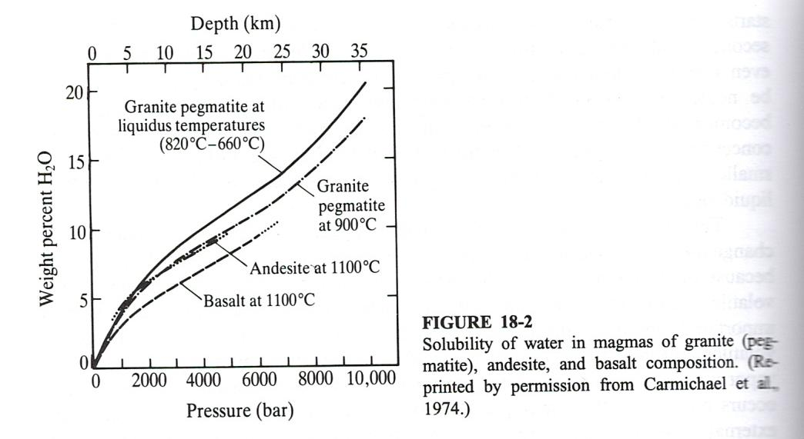

Figure 2-11. From (IVe2/27 p. 482), see original figure text. The solubility of water in magma.

But there are further effects of the water solubility that might be of some interest in the present context, and the source here is (print/24 p. 46). “*Liquid-liquid fractionation does not appear to be a major process by which silicate magmas become differentiated. However, certain melt compositions may separate into two or more immiscible (i. e. unmixable) liquids.”* … “*Iron-rich basaltic melts may separate into a felsic silica-rich liquid and a mafic iron-rich liquid*”. Perhaps, this is what we are seeing in the molten amphibolite from Broborg, see Figure 2-12.

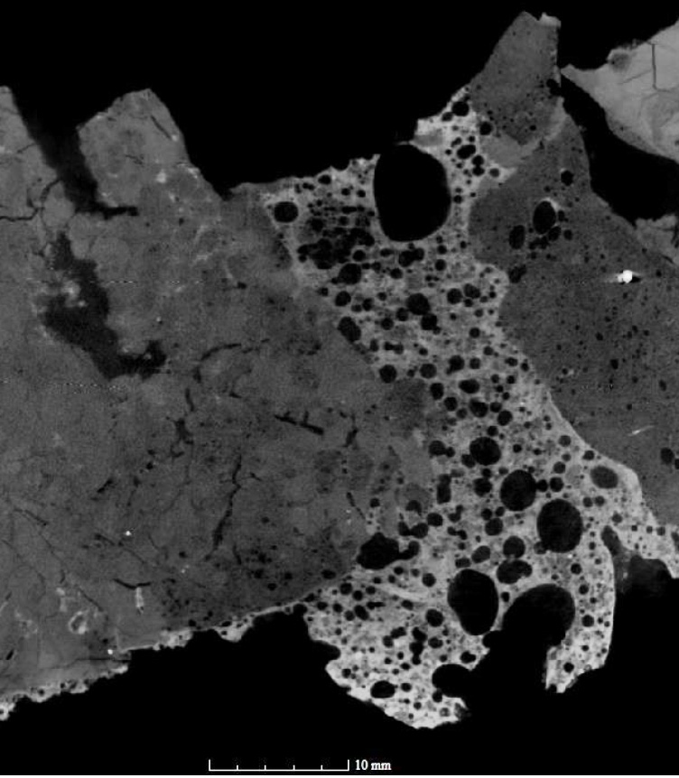

Figure 2-12. A tomographic image of part of the wall at Broborg. Molten amphibolite in the middle and granite to the right and left. Light color corresponds to a higher density. Note the pattern of light and dark glass, i. e. dark and light in the image, pattern in the molten amphibolite.

## 2.5 Further comments on the possible reality during the firing of a wall in a hillfort

Differences between literature data and the reality during the firing of a wall in a hillfort do not comprise only the differences in the stone and mineral material as discussed above. Additional differences include kinetics and transfer of matter.

Firstly, it should be realized that whilst transfer of heat is rapid for < 1 gram quantities in a laboratory, heating of stones in a wall might take some time. Moreover, it may be required that if an appropriate vitrification is to be achieved, there may also be a certain length of time during which the rock in question might need to be held at the appropriate sintering temperature. In the case of (III/38) such a sintering time at peak temperature was estimated to exceed 10 hours.

As will be described in more detail below, some of the events of interest take place at temperatures much lower than that for the onset of the sintering. Such reactions include oxidation of iron and possibly also release of bound water. They may depend on the transport prerequisites such as mobility of oxygen, water and hydrogen. They, in turn, may depend on any fracturing present, including micro-fracturing.

From (print/22 p. 132): “*Diffusion of hydrogen in minerals is generally several orders of magnitude faster than diffusion of larger cations and oxygen, and is especially rapid when controlled by redox reactions*” … .

From (print/22 p. 134): “*Hydrolytic weakening and deformation rates. An overview of the influence of water on rock deformation is given in Kohlstedt (2006). Many experimental studies have examined the influence water has on lowering the temperature of the brittle-ductile transition of quartz (Griggs 1967; Tullis and Yund 1980; Kekulawala et al. 1981; Kronenberg et al. 1986; Ord and Hobbs 1986; Rovetta et al. 1986; Cordier et al. 1988; Gerretsen et al. 1989; Kronenberg and Wolf 1990; Kronenberg 1994; Post and Tullis 1998). The structural OH in natural quartz has a negligible effect on deformation behavior; instead, it is the fluid inclusions that play a major role in structural weakening (Kekulawala et al. 1981; Kronenberg et al. 1986; Gerretsen et al 1989; Post and Tullis 1998)*.”

The brittle to ductile transition of quartz is dealt with in Section 3.3.4.

It might be commented that it may be difficult to distinguish between on one hand dehydroxylation associated with evolution of hydrogen and associated oxidation of iron, versus evolution of water. However, what happens might have an impact on the melting properties in that the formation of iron-III may lead to a higher melting point.

Near the temperature of sintering, some thermodynamically possible reactions may be slow or inhibited for kinetic reasons. Thus, the paths of reaction as well as the end result may vary dependent on the time scale involved. Rapid heating may, e. g. lead to higher temperatures and formation of more liquid phase (glass phase). This may be so because it could take time for incongruent reactions to take place. They might be kinetically hindered by the requirements for diffusion.

A further consideration is the formation of volatiles. If the heating is rapid, then the gases formed might not get enough time to escape through diffusion in combination with the transfer of liquid phase to the grain boundaries thus facilitating the diffusion.

It is pointed out in (Print/41, pp 5-6) that atmosphere may also be significant. Laboratory tests are typically conducted in air or nitrogen, but in a hillfort wall, the fumes contain CO, CO2, H2O, O2, KCl and NaCl. See (print/140, p 140) for the example of burning of limestone.

The conclusion of Section 2 is that caution is warranted with regard to type of rock, and mineral compositions as well as a number of factors which may be different in a laboratory as compared with a hillfort wall. This means that conclusions made in this memorandum must not be regarded as findings, but as possibilities that might warrant further investigation in order to assess what the reality may be, if any.

# 3 THERMALLY MODIFIED ROCK (TMR) AND MECHANICAL PROPERTIES

## 3.1 Introduction

The term ”*Thermally Modified Rock*”, often referred to as TMR, has a specific meaning in that it – at least for the very most part – refers to rock that is fractured or weakened as a result of thermal treatment. A similar term is “fire-cracked”. It is not used here since it is unclear to what extent the term includes rock that is damaged but not fractured, at least not visibly on the surface. Fractures on the inside might well evidence themselves by the special “dull” or “hollow” sound when struck with a hard object as compared to the more sonorous sound from an intact piece of rock. Actually, this method is (or at least have been) widely used in the ceramics industry in order to discover invisible internal defects.

This section, section 3, deals with the thermally induced changes in the types of rock in question in the vitrified wall at the hillfort Broborg, i. e. granite and amphibolite/diabase, see (IVe3/10; III/71). The former comprises quartz and feldspar as well as some mica, most of which is biotite. The amphibolite/diabase contains amphibolite, biotite, feldspar and silica. The section is limited to changes that occur before sintering (or any appreciable sintering), i. e. the temperature range up to around 800 °C. Changes that involve melting are dealt with in Section 4. The temperature of 800 °C is also what can be reached in a wood fire. However, a charcoal fire can get considerably warmer, so there is still the possibility of wood first charring and then becoming combusted (in which case the draft conditions need be changed during the process).

The emphasis is thus on thermal modification and fracture development. For example, and in the case of cooking stones, see section 3.2, the immediate cause of fracture is the thermal shock encountered when the hot stones are immersed into water. The rapid cooling on the surface gives rise to tensile forces which, together with existing defects at or near the surface, lead to fracture.

But this is only part of the story. Before the last time the cooking stone in question was used, it had likely been used a fairly large number of times providing conditions for chemical changes. Minerals like amphiboles and biotites – present in the rocks at Broborg – contain iron-II as well as bound water and are thermodynamically unstable in an oxidizing environment at ambient pressures.

Literature on cooking stones is being reviewed in section 3.2 and other literature in section 3.3.

Healing effects are considered to occur at higher temperatures and are therefore dealt with in section 4.

## 3.2 From archaeological sources; cooking stones

Reference (print / 43) is a chapter in a book and provides a Swedish perspective on Thermally Modified Rock (TMR). The various terms defined do not appear to correspond to terms in English wherefore explanations are provided rather than definitions. It is put forward in the introduction that whilst TMA constitutes much of the prehistoric remains, it has been studied very little, and the knowledge is meager. E. g. little is known as to what extent remains comprise grave mounds of natural pieces of rock on one hand and TMR on the other. Little is also known about the geographical variation of TMR.

The chapter (print / 43) puts forward that a certain piece of rock may be a TMR if it has a hollow sound when struck with another piece. Another indication is if the piece fractures easily. A further item is if the piece has sharp edges. Here, the situation in Sweden is somewhat different from most places elsewhere. In the Uppsala region (which is the region dealt with in the chapter) the ice sheet was at tis thickest during the glaciation. Consequently, the pieces of rock were removed from the bedrock and abrased to rounded shapes. Consequently, sharp edges provide some indication that a piece may be a TMR. Caution is appropriate though, not only because some pieces of rock might have sharp edges still after the glaciation, but also because of mining of ore or fracturing of larger entities for the purpose of dry stone wall construction. The term in Swedish for the mining practice is “tillmakning” but the technical dictionary only comes up with “loosening of rock by heating”. “Tillmakning” was the dominant method for mining in Sweden up until maybe 150 years ago, but the switch to gunpowder and other explosives went on for a long time and depended on the quality of the rock. Of course, having access to sharp-edged pieces of rock was very attractive to the dry stone wall builders since it was much easier to build stone wall using such material as compared to the otherwise mostly rounded ones.

Following (IVe/16): (In Swedish but with a summary in English). Stones have been used in prehistoric times in hearths and as cooking stones. The latter use has persisted up to at least the 19th century. Heaps of cooking stones actually constitute much of the prehistoric remains in Sweden (as well as elsewhere). The practice includes heating of pieces of rock in a fire whereafter the hot pieces are dropped into a vessel of water which then becomes heated, e. g. to boiling, by the pieces of rock.

The stones are damaged in the process, at least after a number of cycles. The immersion into cold water gives rise to strong tensile forces near the surfaces which leads to formation of fractures and in many cases also to disintegration. It is such damaged stones that were discharged to form the heaps mention above. (The mechanisms for fracturing are actually much more complex, and this is discussed further in the following).

Reference (IVe2/24) also describes the situation on thermally modified rock in archaeological remains in Sweden. In addition, the author makes the following remarks as to a simple method to detect if a stone has been subjected to alternation by thermal action:

*“ … Although the method of identification itself has not been recorded in the surveyor’s handbook (Selinge 1969), two generally recognized characteristics of these stones were: 1) fire-cracked stones emit a soft and low, “short” thud or thump when they are hit against another stone, and 2) fire-cracked stones crack apart easily when struck against another stone. To my knowledge, these criteria are still today generally accepted as identifying features of fire-cracked stone.*

*However, the important point here is that these two criteria are not characteristic for all fire-cracked stone. In the above discussion and in earlier archaeological literature, among others, it is clear that there are a variety of different characteristics of this stone material, and these vary. In field survey, the criteria for identifying fire-cracked stone are characteristic for brittle-burnt stone or skörbränd sten, but not for skärvsten generally, which is the less hard burnt, split stone, more angular in form, sharp-edged and firmer in structure. … “*

From (IVe2/15): from the introduction: “*This paper reviews the findings of an experiment conducted to determine how rocks crack under different circumstances. High temperatures and rapid cooling cause rocks to crack and contribute to the way in which they will crack. The way in which a rock cracks is also determined by the material which it is made of. Rocks heated to ca. 540°C, whether gradually or quickly, will crack the majority of the time. Those heated to ca. 315°C or by boiling, will tend not to crack. Rocks heated to ca. 540°C and then cooled quickly will crack considerably, whereas those rocks cooled gradually will tend not to crack. The material which a rock is composed of will cause a rock to crack in a certain manner. The source of a rock will not affect how it cracks. By knowing how a rock cracks under different conditions, one can look at a rock found on a site and recorded as a “Fire Cracked Rock” and determine what really caused the rock to crack and thereby learn more about the activities and life ways of the people who occupied the site.*”

Most archaeological sources only provide very brief information about the type of rock used, frequently claiming lack of competence in geology. The source (IVe2/16) provides some more information, and it is also similar to more brief information elsewhere. Thus, the main rock types at site 33Ro616 (in Ross County, Ohio, USA) identified as FCR (fire cracked rock) are sandstone, quartzite and granite. Sandstone and quartzite are said to be “*similar in terms of their texture and composition*”, and sandstone is described as *“a sedimentary rock formed through the compaction of minerals such as quartz, feldspar, mica, calcite, dolomite, clay, limonite, and hematite*”. Moreover, “*Quartzite is a metamorphosed sandstone with a grain mineral composition that is dominated by quartz* … .” … “*Granite is a hard, coarse-grained igneous rock composed of visible minerals, predominately feldspar with some quartz, mica, and hornblende*”. Hornblende refers to a class of amphiboles, and mica in granite is often predominantly biotite. A photo is provided with some samples of the sandstone (Figure 3 in IVe2/16) showing a fine-grained structure. Granite is described as coarse-grained. It was considered that the size range 5-9 cm constituted the threshold for usability, and thus pieces less than 5 cm were deemed unusable and were discarded.

Continuing with the source (IVe2/16): archaeologists mostly identify fire cracked rock by means of context and experience, the latter meaning discoloration and fracture pattern. But there are also more “technical” methods available such as luminescence and thermoluminescence techniques.

Part of the conclusions of the source (IVe2/16) is as follows:

*“The literature review shows FCR has the potential in inferring past behavioural processes such as resource procurement, type and intensity of cooking and heating activity, occupation duration, and discard pattern. That a standard methodology can be adopt or create to analyse FCR as an artifact class and how such analysis would be applicable and add to the interpretation of a site. However, to fully understand the value of FCR as a research subject, no conclusive assessment of using FCR to infer past activities could be done without locating the parent rock source to interpret how FCR was acquire, and what was its original shape and size.”*

Reference (VIe2/20) has the title “THE EXPERIMENTAL REDUCTION OF ROCK IN A CAMAS OVEN: TOWARDS AN UNDERSTANDING OF THE BEHAVlORAL SIGNIFJCANCE OF FIRE-CRACKED ROCK”, and is about a replication of such an oven and the subsequent analysis of the pieces of rock. A Camas oven is an oven dug out of the ground heated by stones taken from a fire. The procedure gives rise to stones that have been subjected to slow heating as opposed to the quenching achieved when the stones were used for cooking/boiling.

The paper deserves to be read in full, but here are at least a few quotations:

*“In spite of its central role .in prehistoric household activities, fire-cracked rock remains an understudied and undervalued analytical resource compared with its more attractive and traditional counterparts: flaked and ground stone tools, bone implements, faunal and floral remains, and even lithic debitage. A review of the ethnographic literature reveals that few researchers have described the technology of hot rocks (e.g., Downing and Furniss 1968). Likewise, the archaeological literature has few good discussions of variability In fire-cracked rock features found at archaeological sites (e.g., Cree and Cochran 1991 ; White 1975, 1980), and only a few studies have addressed the interpretive potential of fire-cracked rock through distinguishing the general principles or rock fracturing and methods to identify and analyze it in archaeological contexts (e.g., Kritzer 1995; McDowell-Loudan 1983; Lovick 1982; Schalk and Meatte 1988; Thoms 1986, 1989).”*

…

*“Igneous rocks of andesite or basalt composition comprised the bulk of the cobbles used in [he experiments, about 78% by weight, with the remainder primarily composed of quarzite. The first, most obvious finding of our experiments is that the igneous rocks fractured differently from the quartzite rocks. In both the upper and lower heating elements, most of the unbroken rocks remaining after two firings were igneous (between 85% and 96%). A low percentage of the quartzite rocks by weight remained whole--l % in the upper element and 13% in the lower. In contrast, between 21% and 28% or the andesite/basalt rocks remained unbroken after Experiment 2. The finding that igneous rocks are more durable than quarzite suggests that identification of the composition of fire-cracked rock may be important in inferring prehistoric selection criteria for thermal rock facilities. Different rocks break differently, have different rates of degradation, and consequently have different performance characteristics (in the sense of Schiffer and Skibo I 992). These translate: into different technological advantages and disadvantages that may have been known to prehistoric peoples.”*

…

“*Two types of fractures were evident—spalling fractures that created thin, flat potlids, and fractures that broke the core of the rock into blocky fragments. The first type is the result of thermal gradient associated with differential heating rates from the outside portions of the rock to the inside portions (Schalk and Meatte 1988). Blocky fracturing may be a result of thermal mismatch stress, where variability in expansion of the crystalline matrix of the rock breaks bonds between crystals within the rock. While the results of thermal mismatch stress in more grainy rocks, such as granite, appear to lead to crumbling (Schalk and Meatte 1988). the results for both the basalt/andesite and quartzite rocks used in our experiment suggest that exploitation of incipient weaknesses or remnant bedding planes, pores, and incipient cracks within the rocks lead to larger, angular fracturing.* …”

…

“*Our experiments suggest that differences in the fracturing characteristics of rocks affect their reusability. This suggests that prehistoric oven-builders possibly selected materials based on their knowledge of the technological performance characteristics of the rocks, especially thermal shock resistance*.”

The article also contains statistics on the damages of the rocks. Unfortunately, no data is given as to the degree of hydration or the content of iron-2.

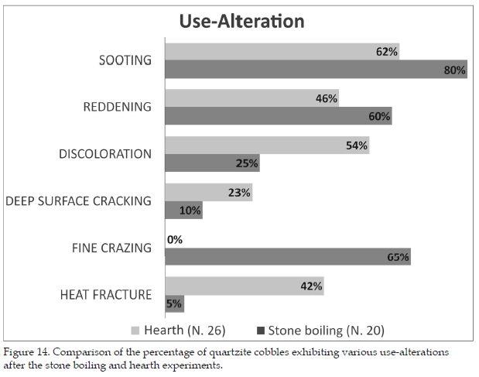

Figure 3-1. From (IVe2/17 p. 44), see original figure text.

Neubauer (IVe2/17, IVe2/21) carried out many experiments on quartzite. Differentiation and comparison were made between “earth oven” as the camas oven above with damages predominantly from heating in the fire – expansion fracturing, and “stone boiling” with damages predominantly from the quenching – contraction fracturing. A compilation of the types of damages observed is presented in Figure 3-1.

Reference (IVe2/13) is a doctoral thesis covering “Hunter-Gatherer Lithic Technology and Function (Chipped Stone, Ground Stone, and Fire-Cracked Rock”. Pages 353 – 361 summarizes work by different archaeologists as regards the resilience among different types of rock towards fracturing in conjunction with heating and cooling. No reference has been found by the present author as to any minerals or chemical rationales for fracturing behavior.

However, the source does deal with the differences in fracturing patterns between heating and cooling, see also Figure 3-2.

Substantial efforts have been made to use the tools of natural sciences for the purpose or understanding the mechanisms behind the fracturing. They will be described in section 3.3. Very little, if any, of this has been carried out by those archaeologists that have looked into thermally modified rock from archaeological sites. Thus, section 3.3 supplements section 3.2 and provides explanation as regards the chemical changes that take place on heating and how they collaborate (consociate?) with the various stresses and strains that come about as a result in the changes in temperature.

Nonetheless, and in all fairness, in (II/19), two archaeologists, one also a petrologist and the other also a metallurgist, have written about “*thermometry of fire-cracked and molten material*”. They had noted, in (print/53), that “*On heating, the divalent iron in biotite is oxidized at temperatures in the range 400-600°C (Smykatz-Kloss 1974).*” And that “*Between 850 and 920°C, biotite decomposes*”.

They maintained the following: “*The oxidation reaction is accompanied by a change in colour from greenish or brownish black to golden yellow. To determine the reaction temperature for biotite from Broborg, slices of gneissic granite have been heated in an electric furnace to various temperatures for 1, 10 and 100 hours. The result of the runs was that biotite develops the golden colour on heating to 500°C. Heating to 450°C, even for 100 hours, did not produce the golden colour. Therefore, the occurrence of golden biotite defines the 500°C isotherm in the excavated section through the rampart of Broborg (Fig. 1). The other isotherm shown, about 1000°C, is defined by the complete disintegration of biotite and the first appearance of melt*.”

Another interesting observation was also made in (II/19): “*Magnetite is a common accessory mineral in most rocks. On heating, magnetite oxidizes in two steps, between 275-450°C to maghemite, and between 480-700°C to hematite (Mackenzie and Berggren 1970; Smykatz-Kloss 1974). The wide range of reaction temperatures precludes the use of magnetite as an exact geothermometer. However, the reactions result in a decreased magnetic susceptibility of the rock, a property that is readily measured in the field with appropriate instruments.*

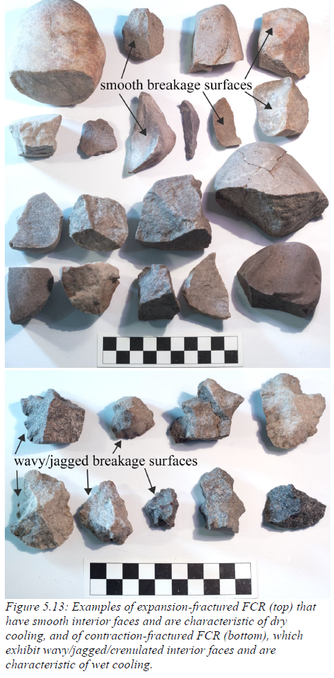

Figure 3-2. From (IVe2/13 p. 228) see original figure text.

*At Broborg (Kresten et al. 1993), cracked and exfoliated boulders of gneissic granite are found within the hill-fort. While many archaeologists believed that the boulders showed evidence of strong heating, e.g. due to large wooden constructions having burnt, most geologists attributed the appearance of the boulders as due to weathering. Measurements showed that the boulders inside the hill-fort did not differ in susceptibility from background samples taken in the forest. Both have susceptibilities of about 1700x105 SI units. Thus, the assumption of fire-cracking could be discarded, as it would have resulted in susceptibilities of about 1000x105 SI units.”*

The following is put forward in (IVe2/15, p. 24): “*A colleague once asked me on what were the criterias in identifying and verifying FCR. My answer was 80% context and 20% experience.*”

In the cases of rocks containing biotite, such as granite and amphibolite at Broborg, such assessments can thus instead be made based on measurements of the magnetic susceptibility.

Again, and in all fairness, a further example has been found where archaeologists actually utilize natural science methods in order to make assessments (at least the article was published in an archaeological journal, namely “*International Journal of Architectural Heritage*”). This review article mentions a number of techniques for materials characterization. Specifically, it maintains that granite “*is one of the hardest and must durable types of stone, with vast aesthetic possibilities (Pires, Rosa, and Dionísio 2014). However, its heterogeneous mineralogical composition and susceptibility to decay has led researchers to the study its behavior at high temperatures (e.g., Pires, Rosa, and Dionísio 2014; Vazquez et al. 2016)”*.

The article also mentions that the “flexural strength” of granite decreases by 18 % after exposure to a temperature of 200 °C, and by 61 % after exposure to a temperature of 600 °C. Maybe the reference quoted has the details, but nonetheless, granites can have strongly varying contents of bound water as well as iron-II, and thus also show large variations in “flexural strength” after a fire.

## 3.3 Thermo-mechanical behavior; natural sciences sources

### 3.3.1 Introduction

This section deals with the mechanisms for thermal alteration before the onset of any appreciable melting as presented in the natural science literature. Thus, the upper limit in temperature is around 800 °C. The thermal properties of the minerals involved, including oxidation and dehydration / dehydroxylation, are briefly described in section 2, and information in the archaeologic literature on the fracturing of stones is presented in section 3.2.

The thermomechanical behavior relates to (amongst others?) the following parameters:

* Occlusions
* Oxidation, cf. above
* Dehydration / dehydroxylation, cf. above
* Phase transitions, including quartz
* Stresses and strain due to temperature gradients, i. e. much of the reason for TMR (Thermally Modified Rock)
* Significance of anisotropic thermal expansion in a single crystal
* Significance of anisotropic thermal expansion between different crystallites
* Grain size, larger effect for larger sizes
* Unisotropic strain versus stress relations (intra- and intercrystalline)
* Diffusion along chains / sheets / grain boundaries
* Atmosphere: O2, CO, H2, H2O
* Diffusion of, in particular, H2 O2 and H2O
* Duration

Diabase and granite were formed at depth and at high temperature deep in the crust of the earth. They are not in thermodynamic equilibrium with the present surficial ambient environment, and have a tendency to oxidize and dehydroxylate as well as undergo various other paths of weathering. According to (IVe/13) this is not a strictly surficial phenomenon on the pieces of rock, but involves fissures and fractures in the interior down to a very small scale. Such channels enable transport of reacting species and reaction products, and thus facilitate the weathering.

These reactions take place also at ambient temperature. Thus, there is no limit as to when alteration mechanisms may start; it is largely a matter of speed/rate which of course for the very most part increases with increasing temperature.

Such attacks in fissures and fractures are of course hugely supported by such mechanical action that has led to that fissures and fractures have opened and closed or at least changed in volume. This would call for transport by flow rather than by diffusion in a condensed phase.

But do such stress corrosion related mechanisms explain why pieces of rock fracture on repeated thermal cycling? There are disintegration mechanisms that do not require chemistry, e. g. fatigue. No definite answer can be given here as no article has been found that deals with this question (and, for instance, carries out tests in different environments). But in practice, deterioration is much more rapid during thermal – and thereby also mechanical cycling – and it is assumed in the following that these phenomena are synergetic.

A related observation is that in many cases, experiments have been carried out without full control of various parameters, such as moisture. This is of course in addition to other obstacles to interpretation for the case of Broborg: e. g. difference in chemical and mineral composition as well as the time allowed for reactions.

### 3.3.2 Crystallographic considerations

It is well known that materials like those in question here often show a “brittle” behavior, i. e. they have a high inherent strength but undergo brittle fractioning at a small fraction of their theoretical resilience. The simple explanation to this is that there are “flaws” or “discontinuities” that focus the forces onto a small volume. Actually, there are internal structural features that facilitate failure, and that do so to an increasing extent if combined with thermal stresses and thermal cycling.

The rocks in question consist mainly of crystalline matter, and with crystals of different chemistries packed together. This implies that internal stresses will arise when the temperature is changed due to differences in the thermal expansion coefficients. For the lowest symmetry, they are represented by six numbers for each phase, i. e. by an ellipsoid, see <https://en.wikipedia.org/wiki/Ellipsoid>. In general, the ellipsoids of different crystallites are randomly oriented in relation to each other, that is, if this is the case for the crystallites themselves.

Could this actually be of any practical significance? Well, look at the following example from (IVe3/20): Thermal expansion and effect on cracking.

From (IVe3/20, p. 906). “*The thermal expansion ellipsoid is very anisotropic in all plagioclase, with the direction of maximum thermal expansion (e3) accounting for 70% or more of the total volume expansion (Fig. 6). This major deformation is more than twice that in the intermediate direction (e2), whereas in the third direction (e1), which is close to [132], the thermal expansion is quite small and negative. Anisotropy increases very slightly with anorthite content; in albite the ratio between the three principal axes of the strain is 1:0.43:-0.18, whereas in anorthite it is 1:0.32:-0.19. As the strain along e1 is almost negligible, the thermal expansion can be described as essentially the expansion of the plane defined by the e2 and e3 axes. This anisotropy of thermal expansion is very similar in pattern to the anisotropy of expansion induced by exchange of the extra- framework cations. Because the direction of maximum expansion lies close to the (100) plane normal, the anisotropy has been attributed to the intrinsic flexibility of the ‘‘crankshaft chains’’ of tetrahedra that are the characteristic topology of the feldspar structure (e.g. Brown et al. 1984).*”

The thermal expansion coefficients for the main axes in plagioclase are shown in Figure 3-3.

Moreover, any stresses applied will not give rise to the strains normally encountered in metallic materials (which mostly have a high crystallographic symmetry). Instead, and according to (IVe3/18) a 6 x 6 symmetric matrix is required for the lowest symmetry (triclinic, 21 independent matrix elements) to describe the relation between stress and strain. Such matrix elements are listed in the paper just quoted for each of the Laue classes. The implication for granite and diabase is that each mineral grain reacts in its own way to any external forces applied. Moreover, such reactions will also take place as a result of any thermal expansion.

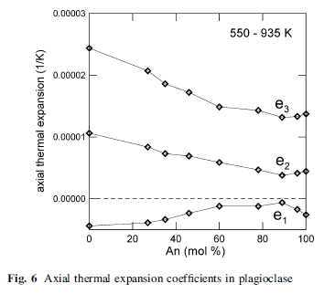

Figure 3-3. From (IVe3/20, p. 906), see text in the figure. The thermal expansion coefficients for plagioclase. It is the values for the three main axes that are illustrated. (Their orientation may change with temperature, at least in principle).

The consequences of these effects are larger the larger the grains. It might thus be expected that – assuming everything else is equal, which it of course is not – that the effects are more important for granite as compared to diabase.

### 3.3.4 Heating experiments

(IVe3/17) Paul et al. 2022. *A review on the impact of high-temperature treatment on the physico-mechanical, dynamic, and thermal properties of granite*.

Please observe that this is a very recent paper which is of special value in view of the fact that it is a review paper.

Mostly, it is the Youngs modulus that has been determined. There are substantial differences between the different values obtained, and this was assessed to be due to differences in the material as well as the laboratory procedures.

There appears to be much more data on granite as compared to diabase. This may be related to the extensive use of granite for various constructions.

The review paper also presents data on porosity from six sources and concludes that the porosity as well as the thermal damages “*show a steep increase with an increase in temperature*”.

(IVe2/3) Wang 2018. *Experimental Study on Damage Mechanical Characteristics of Heat-Treated Granite under Repeated Impact*

IVe2/3: Wang. Many experiments with heat treatment and subsequent mechanical tests. Substantial deterioration in granite for temperatures around 400-600 C. No reason given. % of minerals in granite. 8 % biotite. Repeated impact.

(IVe2/18) Mahabadi 2012. *Doctoral thesis: Investigating the micro-scale heterogeneity and microstructure on the failure of mechanical behaviour of geomaterials*.

From p. 87: “*This heterogeneous crystalline rock consists of approximately 71% feldspar, 21% quartz, and 8% biotite*.” Thus, the sample used has a somewhat high, but still relatively normal content of biotite.

From (IVe2/18, p. 91 and ii-iii):

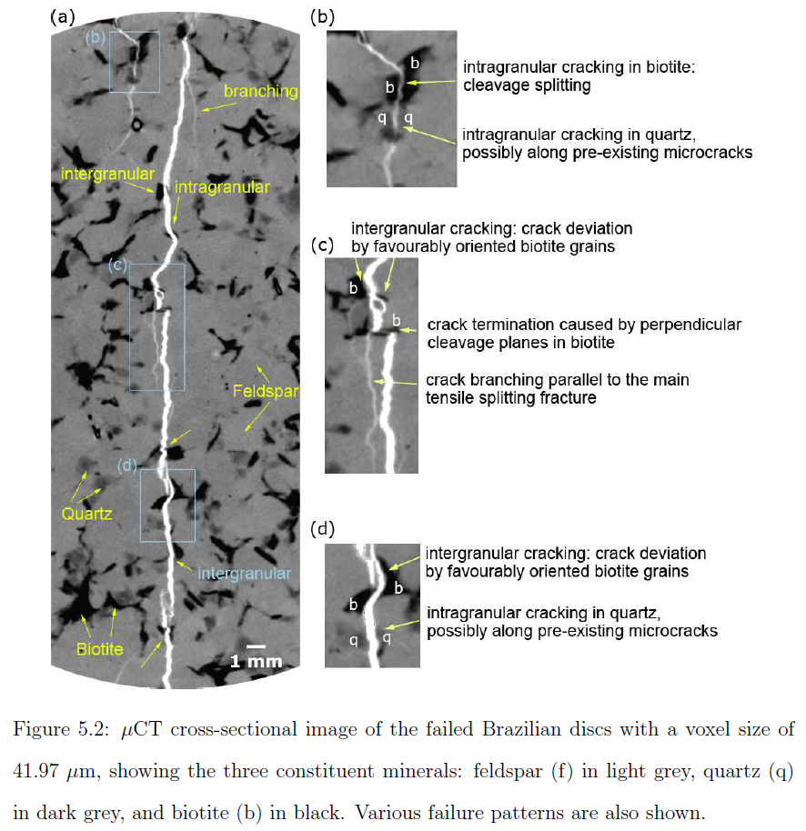

Figure 3-4. From (IVe2/18, p. 91), see text in figure.

From (IVe2/18, pp. ii-iii) “*The mechanical response of geomaterials is highly influenced by geometrical and material heterogeneity. To date, most modelling practices consider heterogeneity qualitatively and the choice of input parameters can be subjective. In this study, a novel approach to combine detailed micro-scale characterization with modelling of heterogeneous geomaterials is presented. The influence of micro-scale heterogeneity and microcracks on the mechanical response and brittle fracture of a crystalline rock was studied using numerical and experimental tools. An existing Combined Finite-Discrete element (FEM/DEM) code was extended to suit heterogeneous, discontinuous, brittle rocks.*

*By conducting grid micro-indentation and micro-scratch tests, the Young’s modulus and fracture toughness of the constituent phases of the rock were obtained and used as accurate input parameters for the numerical models. The models incorporated the exact phase mapping obtained from a mCT-scanned specimen and the existing microcrack density obtained from thin section analysis. The results illustrated that by incorporating accurate micromechanical input parameters and the intrinsic rock geometric features, the numerical simulations could more accurately predict the mechanical response of the specimen, including the fracture patterns and tensile strength.*

*The numerical simulations illustrated that microstructural flaws such as microcracks should be included in the models to more accurately reproduce the rock strength. In addition, the differential elastic deformations caused by rock heterogeneity altered the stress distribution in the specimen, creating zones of local tensile stresses, in particular, on the boundaries between different mineral phases. As a result, heterogeneous models exhibited rougher fracture surfaces.*

*mCT observations emphasized the influence of heterogeneity and, in particular, biotite grains on the fracture trajectories in the specimens. Favourably oriented biotite flakes and cleavage splitting significantly deviated the cracks. The interaction of the main crack with perpendicular cleavage planes of biotite caused strong crack deviation and termination.*

*Considering heterogeneity and the strength degradation caused by microcracks, the simulations captured reasonably accurate mechanical responses and failure mechanisms for the rock, namely, the nonlinear stress-strain relationships. The insights presented in this study improve the understanding of the role of heterogeneity and microstructure on damage and mechanical behaviour of brittle rock.”*

Conclusion 5 on p. 146: “*X-ray mCT is used to characterize the failure mechanisms and damage of failed laboratory specimens non-destructively. It is found that mineral grains, in particular, weaker grains, divert the fracture trajectories. In the granite material used for this study, biotite grains with their weak cleavage planes significantly influence the local fracture paths (Chapter 5)*.” (No underlining in the original).

See also Figure 3-4.

IVd/8 and same at IVe4/9) Nordlund 2014. “*Impact of fire on the stability of hard rock tunnels in Sweden”*

(IVe4/9) Saiang at IVe4/6 is one of the coauthors. This paper was discovered late in the process, but contains in just one paper much of what we are looking for: It is about safety of tunnels and other underground rock constructions in conjunction with fire. It includes gabbro, granite and schist, but a drawback is that the qualities chosen do not contain much of hydrates. It does not seem to have been realized by the authors that, generally, hydrated minerals containing iron-II are more susceptible to changes and deterioration than the corresponding ones without these features. Nonetheless, the following is included:

* Mechanical properties of heated specimens
* Mineralogical changes during heating – slowly and in air
* Microcracking induced by heating. This includes a discovery that on further heating, microcracks join to form larger cracks
* Acoustic emissions
* Modelling

Actually, it is preferable for the reader to go directly to this paper.

This paper makes the reading of paper (IVe4/6) rather superfluous, and it is not referred to any further here. The two papers have partly the same authors.

The following quotation from p.50 in (IVe4/9) might be added: “*The changes in the physical properties of rocks as a function of thermal cracking is a subject of great interest in different sectors such as safe design of nuclear and toxic waste repositories and underground structures. These changes may have adverse consequences on the integrity of the rock mass. For example, stability of the tunnel structure is a key issue when concerning fire. The effect of temperature on rock properties has been widely studied on laboratory-scale specimens. Although numerous experimental programs have been conducted on the mechanical behaviour of thermally loaded rocks, the evolution of micro-cracks with respect to temperature is still not completely understood. Furthermore, most of the previous research focused on granitic rock, gabbro and to a lesser extent, on limestone at temperatures up to 600°C. A number of researchers (Heuze, 1983; Homand and Troalen, 1984; Hommand-Etienne and Houpert, 1989; Duclos and Paquet, 1991; Jansen et al. 1993) have investigated the development of thermal cracks by continuously monitoring AE {= Acoustic Emissions, my comment} generated during thermal cycles in granite specimens. They showed that, at high temperatures, micro-cracks open and coalesce to form a macroscopic fracture. The literature review showed that the rock behaviour during and after high temperature in tunnel fires is an important but poorly understood issue, especially for hard crystalline rock such as gabbro, granite and schist. Furthermore, several properties, e.g. grainsize, inhomogeneity, mineral composition, porosity, rock strength, fracture toughness etc. and conditions which promote the tendency of rock to fail have still not been well investigated at very high temperatures.”*

The following might also be reiterated: “*By 1100°C the samples were highly friable and crumbled easily upon compression. In conclusion, the exposure of rocks to any temperature elevation, especially that caused by a tunnel fire which is of a much higher magnitude, will certainly affect the chemical and physical properties of exposed rocks. This will then, in turn affect the mechanical properties of rocks.*” “Any temperature elevation” should here be understood to mean up to 1100 °C. What may take place at higher temperature is dealt with in section 4 in this memorandum.

Note that in this work, temperature was changed slowly, thus allowing time e. g. for the biotite to react, cf. section 2.4.

(IVd/11) Vázquez 2015. Influence of mineralogy on granite decay induced by temperature increase: Experimental observations and stress simulation.

(IVd/11) p. 58: “*Eight granitic rocks were heated to less than 400 °C and their decay patterns were observed and quantified by means of scanning electron microscopy. Heating was also modeled by finite-element simulations (OOF software) with polymineralic microstructures. Quartz, feldspar and biotite contents were used as a variable in the model in order to elucidate the influence of mineralogy on the thermal-elastic response of granites. Real and modeled heating showed similar trends of microcracking in microstructures and of thermal expansion coefficients. Microscopic observations of real samples revealed mainly intragranular microcracks in quartz, opening of cleavage plains and deformation in mica. Simulations confirmed that in spite of the high thermal and anisotropic expansion of quartz, the microstructure of rocks with large amounts of quartz does not necessarily experience large stresses. Biotite produces a concentration of stresses along their grain boundaries. As a result, OOF models with 10% biotite showed higher stresses than mono-mineral ones. Thermal expansion coefficients of real granites fitted within the limits of the simulated ones proving once more the success of using finite element modeling applied to polymineralic rocks*.”

(IVe2/5), title: “*Mechanical behavior of granite up to 800 C including stress vs strain characteristics*”. … “*The detailed com-position of this rock is as follows: 11.12% quartz, 59.85% feldspar,21.56% biotite.*” Please note that this granite has an exceptionally high content of biotite. In Sweden, granite contains mostly less than 10 % of biotite, and usually only a few percent. Thus, the effects of biotite in granite are likely exaggerated in this paper in relation to circumstances in Sweden.

From p. 180: “*A detailed understanding of the thermal damage and failure mechanical behavior of granite at elevated temperatures is a key concern in nuclear waste disposal engineering, underground coal gasification, and heat mining in enhanced geothermal energy. In this research, uniaxial compression tests were first carried out to evaluate the effect of high temperature treatments (200, 300, 400, 500, 600, 700 and 800◦C) on the crack damage, strength and deformation failure behavior of a granite. The results demonstrated that, in all cases, the crack damage threshold, the strength and static elastic modulus of granite were increased at 300◦C, before decreasing up to our maximum temperature of 800◦C. However, the static Poisson’s ratio of granite first decreased at 600◦C, and then increased rapidly with the temperature. The crack damage and peak axial strain always showed an increase when the temperature was increased. However, the dynamic elastic modulus decreased with the temperature, whereas the dynamic Poisson’s ratio did not depend on the temperature. The gradual increase of temperature results in a more ductile failure of granite. Next, the thermal damage mechanism of uncompressed granite was analyzed by optical microscopic observation. At T = 25–300◦C, the mechanisms were favored by the thermal expansion of mineral grains but no microcracks were observed; at T = 400–600◦C, the mechanisms were contributed by boundary cracks and transgranular cracks in feldspar and quartz grains; and at T = 700–800◦C, the mechanisms were associated with the coalescence of boundary cracks and transgranular cracks. The internal crack evolution process was then monitored during deformation using acoustic emission (AE) monitoring. The results showed that the cracking process of granite depended on the heat treatment temperature. Finally, the deformation mechanism of failed granite at various temperatures was analyzed using X-ray micro CT. During loading, the uniaxial compression stress direction dominated the more brittle fracture process of granite at T = 25–600◦C, which led to splitting tensile main cracks induced along the axial stress, and thermal damage determined the larger ductile fracture process of granite at T = 700–800◦C, which resulted in a more ductile deformation after the peak strength.”*

The brittle-ductile transition is described in Figure 3-5 and related text.

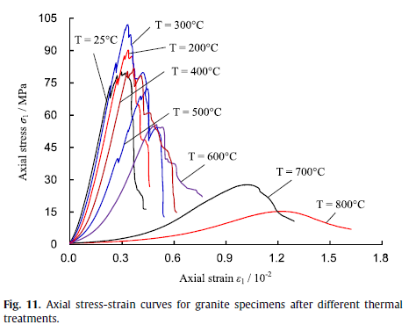

Figure 3-5. From (IVe2/5), p. 187), see text in figure.

(IVe2/7) Isaka 2019. “*Quantification of thermally-induced microcracks in granite using X-ray CT imaging and analysi*s.”

The work was carried out on Harcourt granite which contains as much as 30 % biotite and 70 % quartz plus feldspar. The investigations were based on amongst other techniques micro CT-scanning (CT = computed tomography), and porosity determinations.

The main conclusions are as follows:

* *“The alteration of the microstructural properties of Harcourt granite specimens during heating followed by two cooling treatments, rapid and slow cooling, was evaluated using X-ray imaging and analysis. The following conclusions can be drawn from the results.*
* *Regardless of the cooling method, no considerable microstructural alteration occurs in Harcourt granite rock specimens during heating up to 200 °C. It was found that microcracks form along the grain boundaries (intergranular cracks) and coalesce into larger macrocracks with the increase of preheating temperature over 200 °C. Significant intragranular microcracking occurs at preheating temperatures above 800 °C. Whatever the cooling method, the biotite grains exhibit stable behaviour compared to feldspar and quartz grains, which tend to deform and open up their cleavages without cracking under thermal stresses.*
* *The pore space analysis gives a quantitative and qualitative interpretation of the extent of microcracking in the granite pore structure. The results revealed that the total porosity increases with the increase of preheating temperature, and the induced porosities under rapid cooling treatment are high compared to the slow cooling treatment. Interestingly, the increase of the degree of microcracking in rock specimens results in a reduction of their heterogeneity. In addition, the rapid cooling of heated rock specimens induces more extended microcracks compared to slow cooling. Therefore, the rate of cooling in hot rocks heavily influences the microstructural alterations inside the granite rock matrix.*
* *The pore network models (PNMs) of thermally-treated rock specimens give comprehensive details on the size and distribution of the pores inside the granite microstructure. Regardless of the cooling method, the equivalent pore-throat radii and counts increase with the increase of preheating temperature. According to the results,*
* *rapid cooling induces more extended and interconnected microcracks in granite specimens compared to slow cooling. The complexity of PNM increases with the increase of preheating temperature under both cooling treatments, and the pore and throat size and frequency distributions give detailed information about the complexity of the PNMs of thermally damaged rock specimens.”*

According to the results, rapid cooling in hot rock masses close to the injection points of deep geothermal sites and nuclear waste disposal sites seems to produce significant microstructural alterations through matrix damage, especially at temperatures above 200 °C. The microcracking induced in the peripheral zone of the injection area with slow cooling is not as severe as that in rapidly cooled areas. Therefore, it is critical to incorporate the microstructural alterations induced in deep geological formations during heating followed by cooling treatments in the design of deep underground geothermal reservoirs and nuclear waste disposal sites.

(IVd/6) Wang 2020 “*Thermal damage evolution of granite under slow and high-speed heating conditions*”

and

(IVd/15) Wang 2020 “*Thermal induced cracking of granite: Laboratory investigations and numerical simulations*”

The papers (IVd/6 and 15) are related, and (IVd/6) is the doctoral thesis of Dr. Fei Wang who is also the first author of (IVd/6). The contents of the papers largely confirm the findings presented above. One deviation that may or may not be of significance is that the biotite comprises almost entirely of the mineral siderophyllite which appears to be unusual, cf. Figure 2-2 above.

The abstract of (IVd/6) is as follows:

“*The impact of temperature up to 1000 °C on physical, mechanical, and thermal properties of Eibenstock granite (EG) were investigated. Thermo-mechanical behaviors of EG applying heating rates of 5 °C/min, 200 °C/min, 300 °C/min, and according to ISO 834 standard fire curve were also studied. A supersonic frequency induction heating system was used to conduct the required heating scenarios and to perform uniaxial compression tests under the desired temperatures. P-wave velocity test and Digital Image Correlation (DIC) technique were used for analyzing the cracking behavior of granite with various heating scenarios. Lab testing results show that except for friction angle, all the other investigated granite properties show obvious temperature-dependent characteristics. The maximum temperature has the dominant impact on mechanical properties of granite sample, while the influence of heating rate is relatively small. The DIC analysis shows the crack initiation and progressive crack propagation before the main crack is formed at failure. The final failure patterns prove that different heating scenarios lead to different microcrack structures and consequently influence the failure mode at the macroscopic scale.*

*General temperature-dependent relations of properties for most granites have been deduced based on comprehensive data compilation. These relations are combined with classical Mohr-Coulomb model with strain softening and tension cut-off. A new methodology combining Weibull functions and the real mineral composition of granite is also proposed. It overcomes the shortcomings of using existing methods for the heterogeneity characterization of rocks at the grain size level. The proposed modelling strategy is able to duplicate the thermal induced cracking which results in reduced peak strength, pronounced softening and transition from brittle to ductile behaviour. The simulation results reveal that the thermal induced microcracks are randomly distributed across the whole sample. UCS reduction of granite due to heating is mainly caused by the increase of shear failures at high temperatures. The dominant impact of α-β quartz transition is widening pre-existing cracks rather than the formation of new microcracks. The small strength variation in respect to different heating rates is caused by a different induced cracking structure. The presented results help to understand the damage mechanisms of granite caused by fire or other high temperature conditions, and can be used to develop guidelines for repair and maintenance as well as assessment of risks of tunnels and historical buildings after fire accidents.*”

(IVe2/9) Liu 2014. *“Mechanical properties of Qinling biotite granite after high temperature treatment”.*

The mineral composition of this granite is 37 % plagioclase, 18 % biotite, 17 % quartz, 12 % amphibole, 8 % K-feldspar and 4 % diopside. This gives the impression that the composition is unusual in comparison with granites in Sweden where e. g. the content of biotite appears to be typically below 10 %. Also, the content of amphibole, a hydrous mineral, appears to be very high. The composition suggests that this “granite” should be more sensitive to thermal treatment than typical granites in Sweden.

Nonetheless, it might be mentioned that the paper deals to a large extent with measurements of ultrasonic longitudinal wave velocities. Some of the results are summarized in Figure 3-6

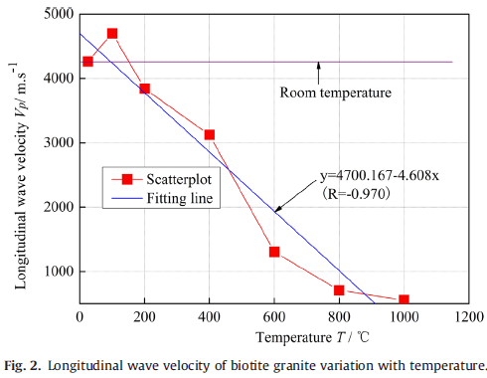

Figure 3-6. From (IVe2/9, p. 190), see text in figure.

(IVe4/5) Knobloch 2022. “*Degradation of a rock bed thermal energy storage system*”

The paper says that “… the goal of this work is to evaluate the performance changes of a 1 MWhth packed bed TES pilot plant operated up to 675 °C in terms of potential degradation mechanisms. TES here stands for “Thermal Energy Storage”. The (intended?) pilot plant is said to have a bed volume of 3.2 m3 and a total rock mass of 5394 kg. The storage material is said to be “diabase”.

The paper deals mainly with practicalities encountered in a large-scale operation. which is of less interest in the present context. However, the paper also mentions the use of amongst other diabase. As mentioned above, diabase can comprise hydrated as well as not hydrated minerals, e. g. amphibole versus pyroxene. Here the paper finds that “*diabase seems well suited to high-temperature TES since its small grain sizes allow heating to a higher temperature before the rock undergoes permanent strain and fracture, in line with literature reporting the unsuitability of coarse-grained rocks …*”. The paper also presents the following finding: “*Rocks with anhydrous minerals with a high heat capacity (e.g. pyroxene, olivine, oxides) are ideal for HTTES systems*.” HTTES = High Temperature Thermal Energy Storage.

## 3.4 Summing up on thermo-chemical and thermomechanical properties before sintering

This section deals with the mechanical and chemical changes that take place in granite and amphibolite / diabase at temperatures well below those for the melting of those types of rock at Broborg, i. e. the upper limit for the temperature considered here is generally around 800 °C.

Thus, the present section combines that which is presented in sections 3.1 – 3.3 above with that presented in section 2.

It has been mentioned that iron-II might oxidize already at rather low temperatures of only a few hundred °C. This temperature appears to depend on the degree and character of diminution as well as on the time scale applied (lower temperatures for slower rate of increase in temperature). Thus, as much of the literature data are on a minute by hour scale, caution should be applied when timescales during a vitrification event are to be considered. In addition, there may be considerable differences in composition between even rock types and minerals with the same name. There might also be substantial differences even between different samples from Broborg.

It has also been mentioned that granite as well as amphibolite have been created at a high pressure and at a high temperature deep in the crust of the earth. They can therefore not be expected to be stable at the same temperature at ordinary ambient pressure. It is difficult to assess or even guess as to what the stability might be like at lower temperatures. Most of the constituent elements, notably, Fe, Ca, Mg and Al form stable hydroxides when their oxides are contacted with water at room temperature. This may suggest that there is some minimum temperature under which dehydration does not take place even if a very long time would be allowed.

It is different with Fe-II and oxidation, where such reactions can be expected to take place (thermodynamically speaking) also down to room temperature. It should be noted that such reactions might take place even with a minimum of channels for transport of species involved in a reaction. It has been found that if the OH- anions in the structure are close to the Fe2+-ions, then the iron might be oxidized to Fe3+ with the simultaneous formation of H2 molecules. Such species are very small, in comparison, and can diffuse orders of magnitude faster than “alternative” species.

Thus, how much of the iron present that may or will be oxidized by this mechanism will depend on some details in the crystal structures in question.

Otherwise, chemical and mechanical changes appear to be interrelated. Differential expansion as a result of temperature differences interacts with the crystal grains involved to create first microfractures, and then on cycling and/or “stress corrosion” successively larger fractures. It can be suspected that when the temperature of 800 °C is reached after slow heating, there may be a network of fractures available for transport of gases, and to some extent also for liquids.

At the highest temperatures, i. e. before the onset of melting, further oxidation of iron may take place as a result of diffusion and flow of air and thereby also oxygen to near the sites of the iron-II. Furthermore, any water released from the rock might be channeled through such a network and dispersed into the surrounding air.

It can also be expected, and at least suspected, that a specimen after such oxidation of iron gets a solidus melting point that is higher than before the oxidation.

The mechanical properties change from brittle to ductile as temperature approaches the upper part of the range considered here. After such an event of slow heating and cooling, and with a substantial number of fractures formed, it can be expected that the material after cooling to room temperature might have lost most of its mechanical strength.

However, see the next section regarding the possibility of “healing” if fractures already at surprisingly low temperatures.

# 4 SINTERING AND NEAR-SINTERING BEHAVIOR

## 4.1 The challenge

The abundance of ceramic products as well as products made of glass in our daily lives might lead us to think that such solid bodies with a high mechanical and chemical integrity will be created as soon as inorganic oxide type of materials are heated. This is not the case, however, as evidenced by the formation of pumice as well as lava in conjunction with volcanic eruptions. Pumice is formed when lava is rapidly subjected to devolatilization, and lava is formed when the molten material still stays molten after having exited a volcano.

And what about when real pieces of rock are to be heated? Will they melt on the surface and fracture on the inside due to pressure build-up from volatiles? What could conceivably make the rock appropriately soft and the generation of volatiles just right in order for the amphibolite to expand between the pieces of granite as shown in Figure 2-12? And how comes that gases are let out whilst fractures are being filled during the same series of events?

Anyone involved in developing ceramics with entirely new compositions can testify that a lot of trial and error is likely to be involved before a functioning process can be found. Textbooks in ceramics carry witness to the same end. The present memorandum does not make any claims on conclusions regarding the appropriate process parameters, but does identify some salient factors to consider.

## 4.2 Prerequisites for sintering

### 4.2.1 Introduction

Previous sections have shown that the amphibolite as well as the granite have undergone substantial changes prior to the onset of any melting. Mechanical stresses as well as dehydroxylation / dehydration have given rise to fractures and channels in the material implying that also the interior of the pieces of rock might be accessible for further changes.

Dehydroxylation and dehydration can also be expected to modify the rock on an atomic scale, or nearly so. Such processes have a paramount impact on the prerequisites for iron reduction after roasting of hydroxide ore as well as for manufacturing of porcelain using kaolinite as one of the ingredients. As this work developed, it turned out that it was easiest to find good literature material for the latter which was also assessed to be the most relevant example.

### 4.2.2 Kaoline and the manufacturing of ceramics

From (print/52, p. 262):

”*Porcelains typically consist of triaxial mixtures of clay (e.g. kaolinite: Al2Si2O5 (OH)4), feldspar (e.g. albite: NaAlSi3O8) and quartz (SiO2). During heating, the water contained within the clay becomes a decomposition product. At higher temperatures, the alkali/alkaline earth elements in the feldspar minerals cause a small amount of liquid phase to form (for that reason, feldspars are often referred to as “fluxes”). The liquid phase fills the interstices between solid particles by capillary action, and the body densifies via liquid-phase sintering. At peak firing temperatures (~1250 °C), reactions among the constituents result in the growth of mullite (Al6Si2O13) with a needle-like crystal habit. During cooling, the liquid phase is retained as a silicate glass. Thus, the fired porcelain generally consists of a glassy phase binding mullite and residual quartz crystals, forming a translucent body. As firing temperatures are increased, more liquid forms, but it is increasingly silica rich (quartz and clay particles become more soluble in the liquid phase) and correspondingly more viscous. Thus, triaxial porcelains avoid slumping despite wide variations in composition and firing temperature. Higher clay content, relative to feldspar, results in the presence of less alkali, and hence less glassy phase, whereby porosity may be retained in the fired product, unfavorably affecting mechanical and dielectric properties. Excessive feldspar content, on the other hand, results in a glassy phase with a high concentration of alkali. This narrows the firing range and forms a glassy phase with a high coefficient of thermal expansion, resulting in a porcelain with diminished thermal shock resistance.”*

From (print/52, pp. 268-269):

***“Thermal analysis of the kaolin minerals***

*Upon heating, kaolinite undergoes dehydroxylation, starting at temperatures of about 450-500 °C, losing its structural water, i.e. the hydroxyl groups in the modified gibbsite layers, forming meta-kaolin (Al2O3·2SiO2). This dehydroxylation reaction, indicated as a sharp mass loss and DT A endotherm in Figure 4, has a latent heat (heat absorption) ranging from 42 to 250 kJ mor1, but typically around 150 kJ mol-1 [7]. Meta-kaolin is structurally similar to kaolinite, but with the lattice broken up so that no long-term atom periodicity exists at the resolution of X-ray diffraction. Prior to dehydroxylation, clays containing these kaolin minerals are sensitive to the action of water (clay masses can be shaped with the addition of water), while this is not the case afterwards. The exotherm onset at ~925 °C with maximum at ~980 °C represents the rapid crystallization of meta- kaolin to a spinel crystal structure (2Al2O3·3SiO2) rejecting silica in the process. This metastable spinel transforms into pseudo-mullite (Al2O3·SiO2) and then into mullite (3Al2O3·2SiO2) through additional diffusional rejection of silica, resulting in a microstructure of mullite needle-like crystals in a silicate glass. All transformations after dehydroxylation are solid-state, and are thus devoid of corresponding mass changes. When pure, well-crystallized kaolinite is the original structure, the small exotherm with a peak at 1250 °C indicates a surge in the formation of mullite (i.e. the secondary mullite exotherm). For disordered kaolinite as the original mineral, this exotherm represents the crystallization of the glassy silica phase to form cristobalite [7]. The dilatometry trace in Figure 4 shows small contraction surges associated with dehydroxylation and spinel formation. The most rapid dimensional change starts at ~1100 °C, as grains sinter together and porosity decreases, aided by the formation of a liquid phase which fills voids and draws solid particles together through capillary forces.”*

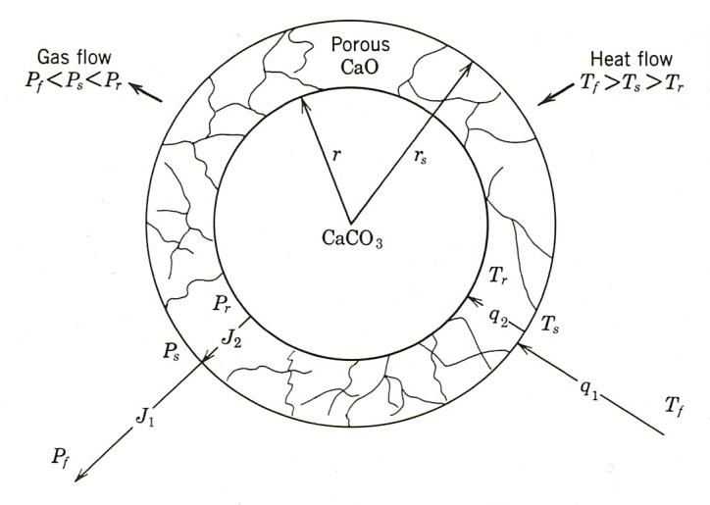

*“Fig. 9.23. Schematic representation of the decomposition of a spherical particle (e.g., CaCO3) of a salt which yields a porous oxide product (e.g., CaO) and a gas (CO2). The reaction is endothermic, requiring heat transfer. The driving forces for heat and mass transport for steady-state decomposition are expressed as temperatures and pressures in the furnace (T1,Pj), at the particle surface (Ts,Ps), and at the reaction interface (Tr, Pr).”*

Figure 4.1. From (print/34, p. 416). Steady-state decomposition through a heterogenous type of reaction. Here the reaction occurs at a sharply defined reaction interface.

Kinetics for calcination and dehydration reactions are often limited by reactions taking place at the surface, see Figure 4.1. However, as stated in (print/34, pp. 419-420), “*some of the clay minerals, kaolin in particular, do not decompose in the manner shown in Fig. 9.23 {i.e. Figure 4-1}; that is, they do not have a heterogeneous reaction interface or a reaction product which breaks up into small crystallites. Above 500°C the water of crystallization is evolved, and a pseudomorphic structure remains until 980°C. The pseudomorph is a matrix of the original crystal structure containing large concentrations of vacant anion sites. Above 980°C the structure collapses irreversibly into crystalline mullite and silica, which releases heat (see Fig. 9.28).*

*The reaction kinetics is controlled by the diffusion of hydroxyl ions in the bulk rather than the heterogenous surface decomposition illustrated in Fig. 9.23 {i. e. Figure 4.1}. The kinetics is thus homogeneous and controlled by diffusion in the solid, which gives a parabolic rate law. The dehydration kinetics of kaolinite is given (1) in Fig. 9.29 for size fractions. A similar situation is observed for the decomposition of Al(OH)3.”*

In view of the above, it appears reasonable to assume that amphibolite as well as the biotite in the granite might well undergo changes on dihydroxylation / dehydration similar to those described for kaolinite above. Such alterations might well take place before the onset of – at least any substantial – sintering.

The rearrangements required on an atomics scale in going from a crystalline ordered structure to one without at least any long-range crystalline order are substantial. They may therefore require time unless melt of some kind is facilitating.

### 4.2.3 Roasting of iron ore

Another similar example is that of roasting of iron hydroxide ore. This is also an area of very high importance to industry and which accordingly has been the subject of substantial research.

Iron is the fourth most abundant element in the Earth’s crust, and can be beneficiated from rather different sources / ores. Today, Sweden, in relation to its moderate size is a large producer of iron ore as well as iron. The ore consists of magnetite. It melts on heating and is not suitable for reduction as mined in a blast furnace. Instead, the ore is converted to pellets consisting mainly of hematite, and such pellets can readily be supplemented with coke and fed into a blast furnace for reduction to iron in a metallic form. The preparation of pellets is the modern version of the historical roasting. Actually, not quite since in the modern practice, unwanted components are separated from the ore by flotation before the sintering.

For the purpose of the present memorandum, it is actually more adequate to look into practices applied for hydroxide types of ore, such as have been used to a large extent throughout history as well as prehistory in Sweden and elsewhere. Actually, in relation to other countries in Northern Europe and even Continental Europe, Sweden was early in introducing iron beneficiation, and according to (Print/59) iron utilization commenced during the period 1000 – 500 BCE. This was well into our bronze age. It might be justified to ask why such scarce elements as gold, copper and tin (bronze) came into use long before iron, and the answer is that beneficiation of iron is actually quite complex technically.

Firstly, if an ore occurs as part of the bedrock, it has to be removed, something that the ancient people refrained from until our Middle Ages. Consequently, iron ore had to be found from more mining-friendly sources, primarily deposits of ore rich in iron-III hydroxides. Inevitably, components not wanted in the iron had to be brought to a molten stage to allow separation, and this set the minimum temperature to around 1200 ºC. (The melting temperature of Fe2SiO4/FeO is around 1173 ºC).

Such a high temperature is relatively difficult to achieve using charcoal, and very difficult to achieve using wood even if it is very dry. Moreover, if the heat is to remove bound water at some elevated temperature, then premium heat at a high temperature has to be sacrificed. This alone calls for a first step involving dehydroxylation.

Moreover, if the reduction takes place at too low a temperature and at too slow a rate, magnetite might form and melt, thus inhibiting the desired processes to proceed.

In addition, the ancient people did not have the capacity to mill the ore and to remove undesired grains/crystallites by means of flotation.

The following is largely taken from (Print/60, pp. 259-293), (Print/61, pp. 71-75, 86-88) and (Print/63, pp39-48, 172).

During the middle of the 19th century, most of the roasting took place in heaps or pits in open air. The arrangement would depend on the characteristics of the ore, but an example would be that 12 to 24 inches – alternatively 6 to 8 feet - of coarsely crushed ore was spread over “billets of wood or lumps of mineral coal. The pattern could be repeated to make a higher pile. The heap was left to burn for days or weeks. Any melting was to be avoided. The process was to be kept at oxidizing conditions. Substances released to the fumes include in addition to bound water, sulfur, arsenic and phosphorous, but the ore could not be made entirely void of these elements.

The chemistry involved is complex, and a good source is (Print/62) which describes the various oxides and hydroxides. A general pattern is of course that whilst iron-II often forms water soluble species in ordinary environments, iron-III species are usually extremely sparcely soluble. This implies that reactions mostly do not go to completion or equilibrium with associated difficulties to analyze the structural forms.

In particular, (Print/61), on pages 367-407, deals with transformations between different forms. This will not be summarized in the following. In the historic and prehistoric iron beneficiation, so-called bog iron (Swedish “myrmalm”) was used for the most part. It can be characterized as iron-III-oxide-hydroxide. It is said to be the ore that is the easiest to utilize.

To summarize:

1. Roasting (in some form) is a necessary step for iron beneficiation. The oxidation can lead to a higher temperature for the onset of melting, thus allowing any bound water to escape first.
2. Roasting implies that all or the very most of the bound water is removed, thus easing the requirement for addition of high quality heat (i. e. heat provided at a high temperature) to obtain the temperature required for the formation of liquid slag
3. Roasting can mean that certain undesired elements be removed. This includes sulfur, arsenic and phosphorous, but also the combustion of any organic material.
4. If a parallel can be drawn from the description above on the formation of pores and fissures to that of heating of amphibolite and biotite, then it can be expected that roasting creates such patterns that facilitate the diffusion of carbon monoxide into the interior of the particles thus allowing reduction of iron inside the particles, thus avoiding clogging on the surfaces.

Perhaps a curiosity: (Print/61, p. 74) deals with slags and fluxes and mentions that hornblende could be and was used as a flux to lower the temperature of melting of a lime-rich slag. An immediate reaction to this might be that silica or feldspar might be more efficient considering the higher content of silica in these materials. However, hornblende – an amphibolite – has a lower temperature of melting and can therefore be expected to be more reactive, although at the expense of a somewhat higher volume of slag. In this connection, it should be remembered that the volume of slag is much less when charcoal is used instead of coke in view of its much lower content of ash.

A possible implication of this is that the ancient people at Broborg might well have had knowledge of the thermal properties of amphibolite from their beneficiation of iron, and not only from their work on high temperature ceramics as mentioned in e. g. (IVe4/11).

## 4.3 The sintering process

The onset of the melting takes place under rather special conditions. As described in some detail above, the starting material originates from high pressure and high temperature conditions deep in the crust where the chemical activity of water was immensely higher than under ambient pressure. During the course of the heating before sintering, much of this water dissipates, and leaves behind a rather disturbed and chemically reactive structure.

Such are the initial conditions when the melting starts. Presumably, the first liquid appears at some grain boundaries, such sites opening possibilities for incongruent melting and subsequent incongruent precipitation. It is to be expected that these processes take place in parallel.

This means that if the melting is interrupted, even at an early state, remelting will be different.

Such effects are mentioned and recognized in (Wadsworth (III/19); Friend 2007 (IVe4/10, p. 1691) where the latter writes as follows: “*It is important to remember at this stage that the described samples were, at the time of their formation melts that were naturally quenched. A sample of the glass from The Torr was found to become liquid at 1260 °C at normal P. This value represents the volatile-free liquidus of the glass and gives an absolute maximum estimate of the temperature needed to melt it in its current state, not when it was produced. When the first melts were produced with a volatile component present, temperatures would have been lower. This result closely follows the melting experiment carried out at surface P on ∼2 g of crush Moine psammite which when heated for 24 h at 1200 °C totally melted (Brothwell et al., 1974).”*

This means that measuring the onset of melting on hillfort glass already formed might not provide correct information on the temperature required for the melting. Moreover, the composition of the gas surrounding the material might also have a huge impact. Presence of oxygen might lead to oxidation of Fe-II to Fe-III and to associated increase in viscosity and temperature for the onset of melting, see (IVe4\11, p. 10). Also, presence of water in the atmosphere may also lead to changes; in this case to a lowering of the temperature for the onset of melting. This is mentioned in (print/34, pp. 506-507) as follows: “***Trapped gases****. In addition to the bloating occasioned by decomposition reactions, trapping of gases within closed pores imposes a limitation on the ultimate density that can be reached during firing. Gases such as water vapor, hydrogen, and oxygen (to a lesser extent) are able to escape from closed pores by solution and diffusion. In contrast, gases such as carbon monoxide, carbon dioxide, and particularly nitrogen have a lower solubility and do not normally escape from closed pores. …”*

It might be reiterated here that what may look like diffusion of water might actually be oxidation of iron-II in combination with diffusion of hydrogen; the two phenomena being difficult to distinguish from each other without further analysis.

Thus, the melting characteristics measured on a specimen may depend on the sample size and the atmosphere as well as the time allowed.

Actually, and as mentioned briefly in Section 4.1 above, trapped gases together with the chemical composition of them and the atmosphere are important parameters for the achievement of a successful sintering process. As also mentioned in Section 4.1, sample size and the thermal cycle are also highly important. Actually, the thermal cycle may be very significant not only for the stages of melting, but also for the degassing, fracture formation and creation of reactive phases at lower temperatures. These processes involve transport, and may therefore well need time to take place appropriately.

Another aspect requiring time is the transfer of heat. As mentioned earlier, the heat conductivity increases with temperature, but it is also well known that crystalline matter transfers heat much better than the corresponding glass phases. (This is why it is possible to use thin glass in windows). As might be interpreted from some of the experiments carried out at PNNL, rapid heating might lead to disintegration due to the pressure build up by trapped gases. Thus, the thermal cycle used by the ancient people at Broborg ought to have included a certain residence time and/or slow heating at and near the maximum temperature and temperature for sintering. Entrapped gases must for the most part escape before the surficial areas have become fully densified.

Thus, in order for an appropriate thermal cycle to be applied, the size of the pieces of rock need be accommodated to the other parameters governing the pre-sintering and the sintering. It was observed during the recent excavation that the pieces of amphibolite had been hewn (IVe4\11, p. 8). It was taken as a proof that the firing had been intentional, but could, in addition, be interpreted to indicate a need for similar sizes of the stones in order to meet the different requirements for an appropriate densification.

This is a relatively sensitive question in ceramics. The temperature needs to be sufficiently high in order for a full densification to take place and sufficiently low such that the shape of a specimen is not altered. Of course, in vitrified fort building, this may be less sensitive, but disintegration is undesirable and was not observed. In only one case did we see evidence of material having been pouring.

In any case, simple calculations show that the very most part of the bound water in the rock will have to be disseminated before densification takes place and the remaining bound water might form some vesicles. It appears from the data presented above that the biotite in the granite as well as amphibolite will lose its water well before the densification takes place, but that some bound water may still be present in the amphiboles in the amphibolite, and thus be available to serve such a purpose.

There is a quote from (print/52, p. 262) in Section 4.2. It maintains amongst other things that in the cased of a typical porcelain, “*As firing temperatures are increased, more liquid forms, but it is increasingly silica rich (quartz and clay particles become more soluble in the liquid phase) and correspondingly more viscous”.* Such possibilities might exist also in the present case, but has not been the subject of closer examination in this memorandum. Any such effects might of course be helpful in achieving a successful densification.

## 4.4 Infilling of fractures

The densification of ceramics is largely due to the effects of surface tension. Generally, the surface tension of different fluids in a ceramic are rather similar, and there is little if any tendency for one species to spread over another (at least one for them need to be in the liquid state). The governing issue is instead the surface tension between a ceramic component and air. This leads to liquid accumulating onto the grain boundaries, thus allowing for diffusion in the liquid state and relocation of matter, hence the densification.

In the cases of various discontinuities in heat affected granite and amphibolite it is to be expected that liquid preferentially fills such available pores and minute fractures.

Moreover, and as described in Section 3.3.4, at the temperatures in question, the stone material is not only partially filled with liquid, but also ductile. This calls for expansion due to residual degassing and vesicule formation leading to expansion and attachment between the various pieces of rock leading to strong mechanical bonds between the different pieces of rock at room temperature.

This has been observed in the two excavations carried out at Broborg (IVe4\11, p. 8), where it was found that sledgehammers had to be used in order to break up the structure.

Similar observations have been made by Wadsworth and coauthors (III/19, p 7) who write the following: “*Ample evidence exists to demonstrate that exposure to high temperature generally decreases the bulk strength of building materials by inducing microcracks (Hajpál, 2002; Heap et al., 2012). Vitrification however, achieved by the significant sintering of blocks and interstitial particles in dry-stone fort walls in the presence of a partial melt, is another matter. Based on evidence from sintering experiments on glass fragments we have previously shown that such sintering results in a dramatic increase in material strength (Vasseur et al., 2013). We therefore speculate that the firing of Iron Age fort walls to temperatures where significant vitrification is achieved through sintering is likely to result in significant strengthening.*”

Surface diffusion can be surprisingly rapid, but, as just mentioned, the “incentive” in terms of energy for species to diffuse across oxide material surfaces is small. Certainly, surface diffusion cannot at all be excluded as the main mechanism for fracture filling, but there is, nonetheless another mechanism that might possibly contribute substantially, and maybe even more: condensation of volatiles.

At the temperatures in question, charcoal, and especially charcoal from tar beneficiation which have a much higher ash content, may release vapor containing KCl and other volatile species containing the elements K and Na. As is described in (IVe/22-26) much of the K in the wood /charcoal vaporizes and can be expected to condense on the surfaces of the pieces of stone. This resembles the process for stone glazed pottery, see <https://en.wikipedia.org/wiki/Salt_glaze_pottery>. In the process, chlorine is vaporized and potassium as well as sodium forms a glazing of silicate. Such surface layers (if formed) might diffuse or even flow to fill also larger fractures and fissures.

## 4.5 The modern versions of the vitrified rock at Broborg

Unresolved riddles include why Broborg and its extensive vitrification for construction purposes might appear to be the only example in Sweden on the application of this method to build strong structures. Of course, one can point out that eventually, the Swedes too learned to make and use concrete and mortar. On the other hand, ceramics are used today, and on a grand scale, to build strong structures. One is of course the use of bricks. But the other one is expanded clay aggregate, see <https://en.wikipedia.org/wiki/Expanded_clay_aggregate>. The aggregates constitute small balls, a few centimeters in diameter. They are made of clay that has been sintered at around 1200 ºC in a rotary kiln. They can be used as they are or in the form of blocks in which the balls have been cemented together using concrete. The blocks are light and can be utilized for structure as well as thermal insulation.